1. Setup:

Hadoop:

Checking Java Installation in the local system:

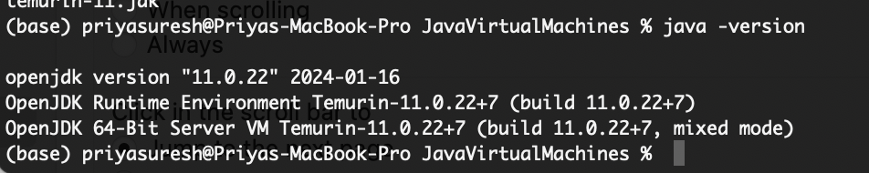

Must update Java home in hadoop-env.sh file once Hadoop is installed.

export JAVA_HOME=/Library/Java/JavaVirtualMachines/temurin-11.jdk/Contents/Home

Installing Hadoop for HDFS:

$brew install hadoop.

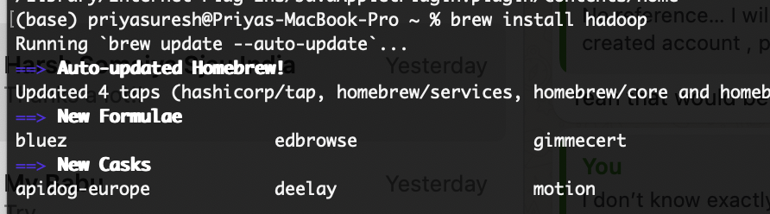

Going to the default hadoop directory



nano hadoop-env.sh

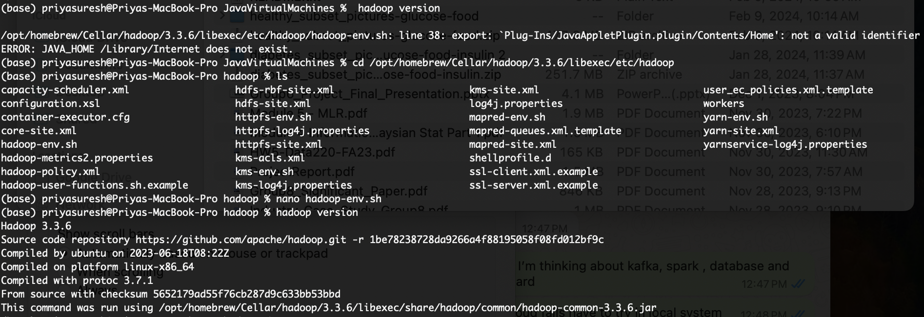

Core site XML file set up in hadoop to use HDFS:

hdfs://localhost:9000

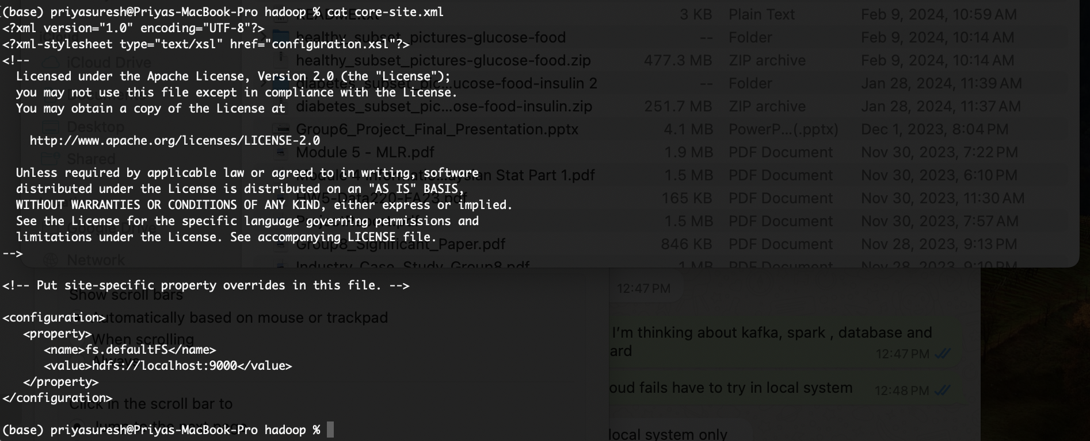

hdfs-site.xml updated as shown below:

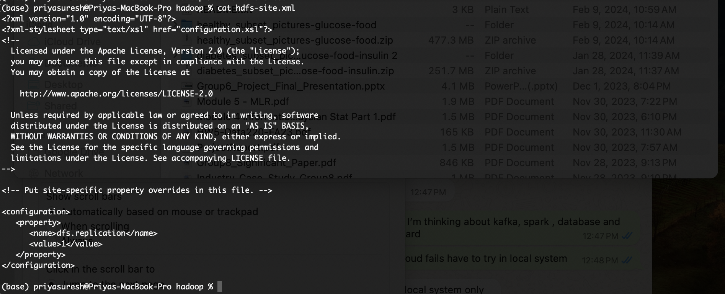

MapReduce

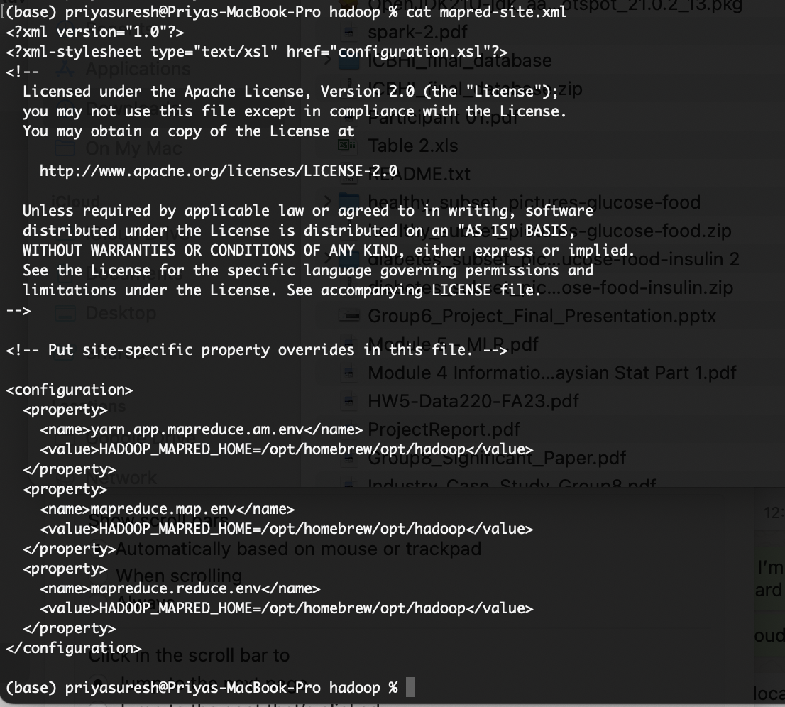

Yarn:

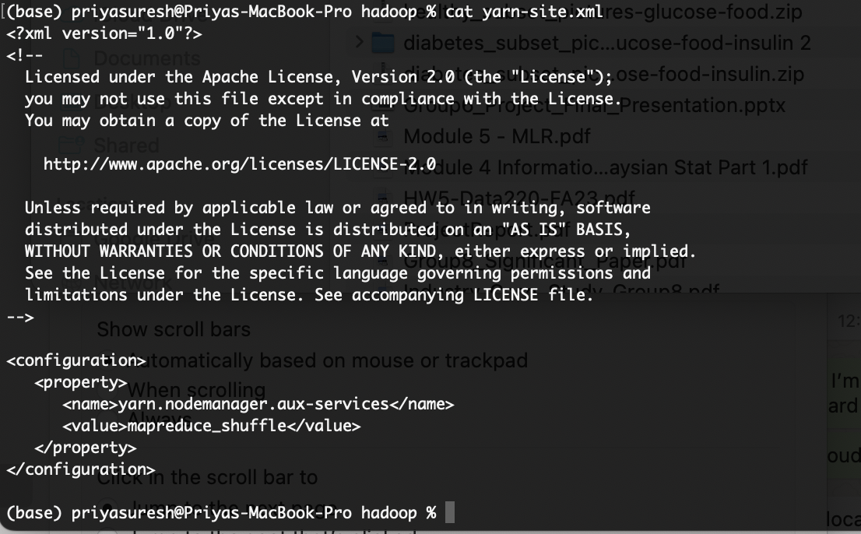

Starting HDFS and hadoop services:

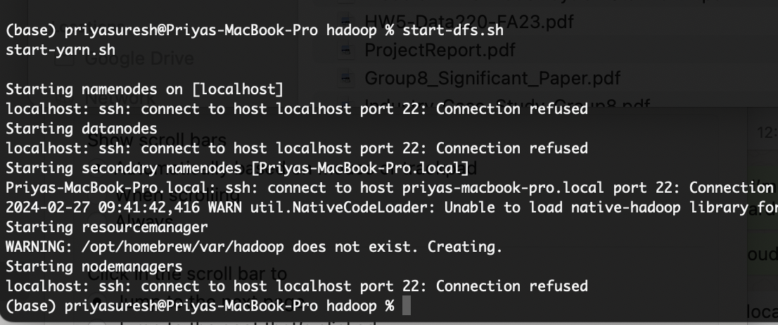

To fix above error, generating ssh key

ssh-keygen -t rsa -P '' -f ~/.ssh/id_rsa

cat ~/.ssh/id_rsa.pub >> ~/.ssh/authorized_keys

chmod 0600 ~/.ssh/authorized_keys

chmod 0600 ~/.ssh/id_rsa

Enabled remote login for the terminal in the system preferences setting to avoid this error.

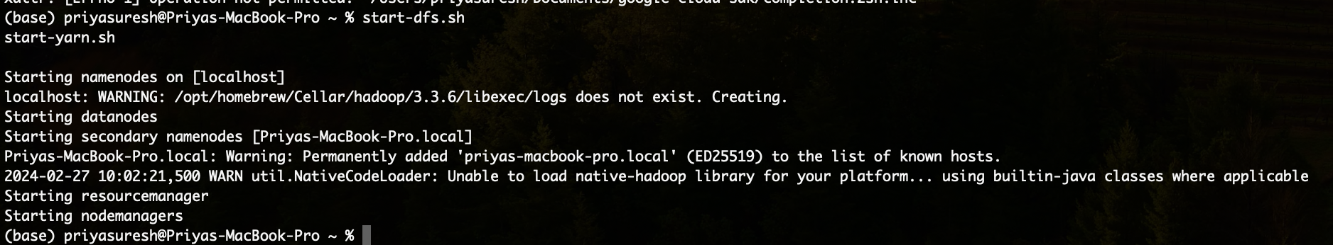

Formatting or initializing namespace for Hadoop file system:

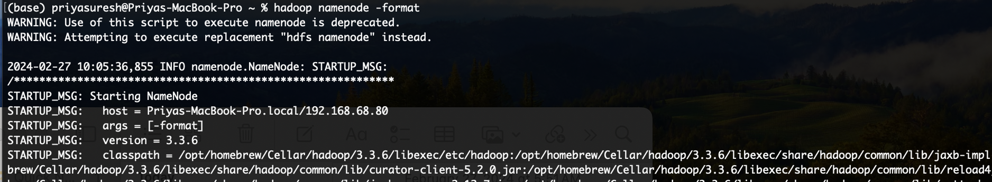

Verifying the status

base) priyasuresh@Priyas-MacBook-Pro ~ % jps

1490 DataNode

2387 NameNode

1621 SecondaryNameNode

1814 ResourceManager

2952 Jps

1913 NodeManager

(base) priyasuresh@Priyas-MacBook-Pro ~ %

[**http://localhost:9870/**](http://localhost:9870/)

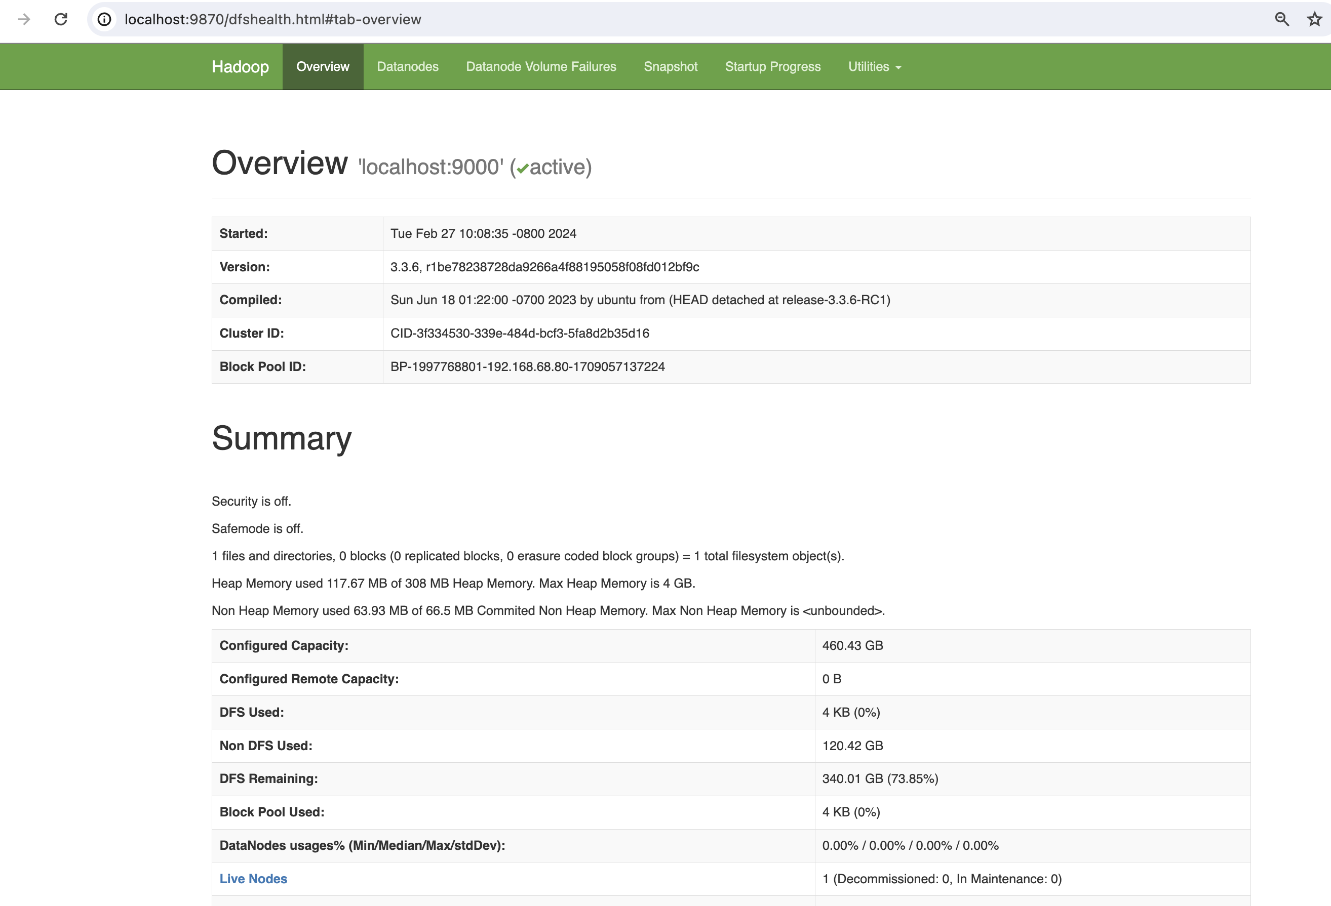

**Created new text file and added to hdfs file system:** 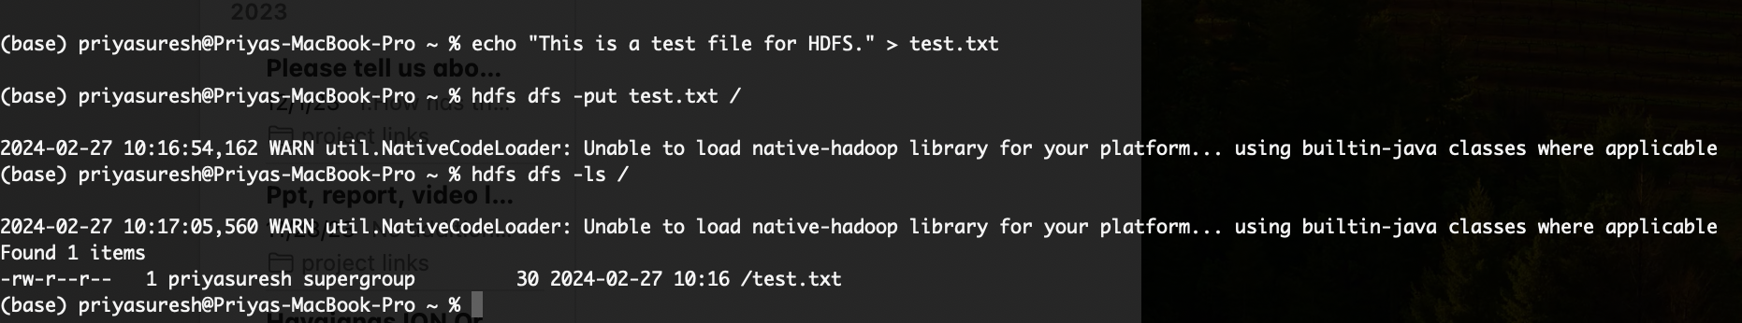

The file is visible in the web browser as well:

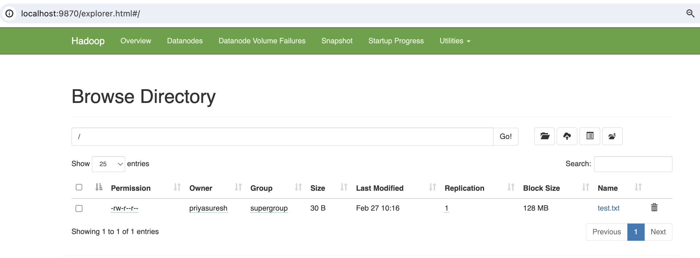

**Technical Difficulty for Hadoop Installation in MAC M1:**

* I had an issue with Java version 8 installed, and JDK was not installed on my machine. So, I uninstalled the current Java in my local system and installed Java version 11 by manually downloading the JDK package from the official website. Java 11 worked with the Hadoop version.
* I had SSH issues after installing and editing the configuration files in Hadoop. I fixed this by enabling full disk access in the system preferences and enabling remote login access for the terminal. I closed the terminal and restarted the system, and then the Hadoop installation worked.
* I referred the blog below for installation steps:

[**https://medium.com/@MinatoNamikaze02/installing-hadoop-on-macos-m1-m2-2023-d963abeab38e**](https://medium.com/@MinatoNamikaze02/installing-hadoop-on-macos-m1-m2-2023-d963abeab38e)

**Kafka Setup:**

I have java already installed in my system and installing Kafka using brew install Kafka command.

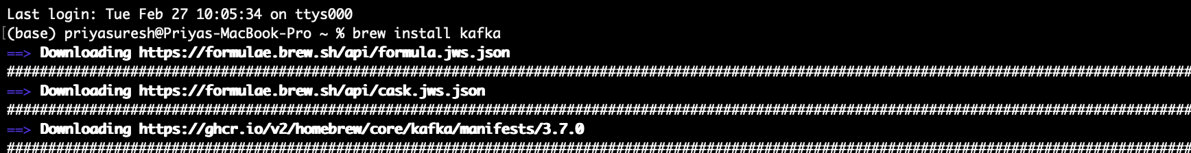

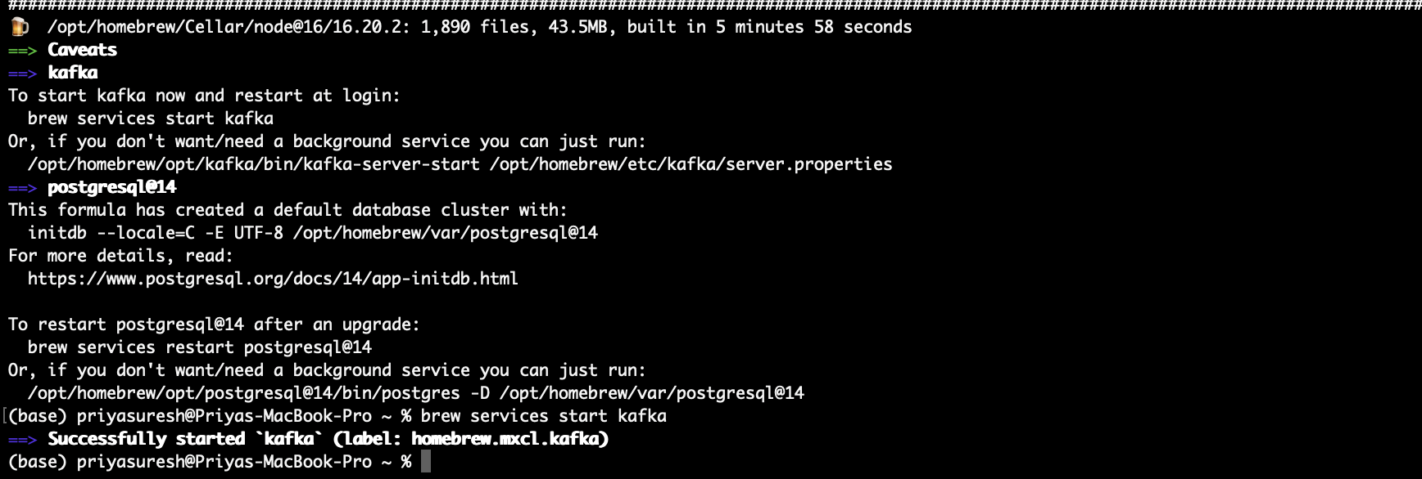

Started Kafka by enabling the background services.

**Zookeeper started:**

Finding the place where zookeeper.properties reside in my local system fixed the error and below command with right location used to start the zookeeper.

zookeeper-server-start /opt/homebrew/etc/kafka/zookeeper.properties

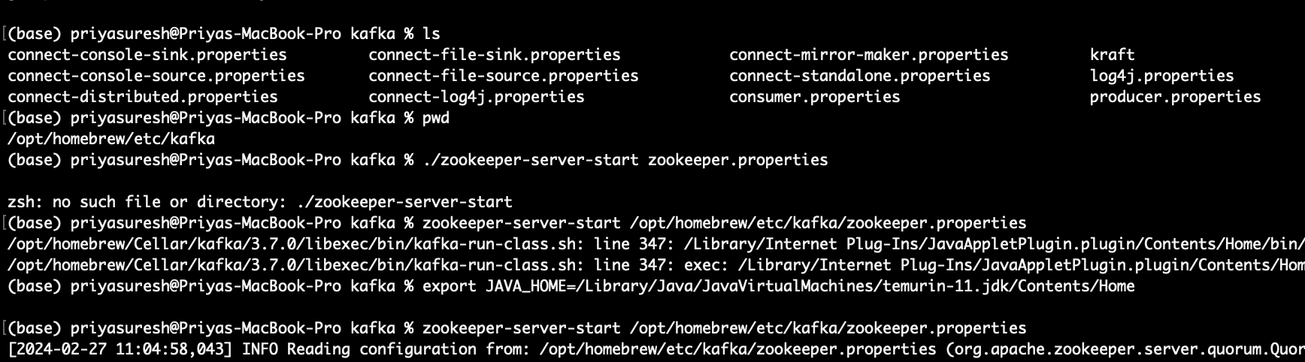

Setting the Java path again fixed the Java not found error, and Zookeeper installation started.

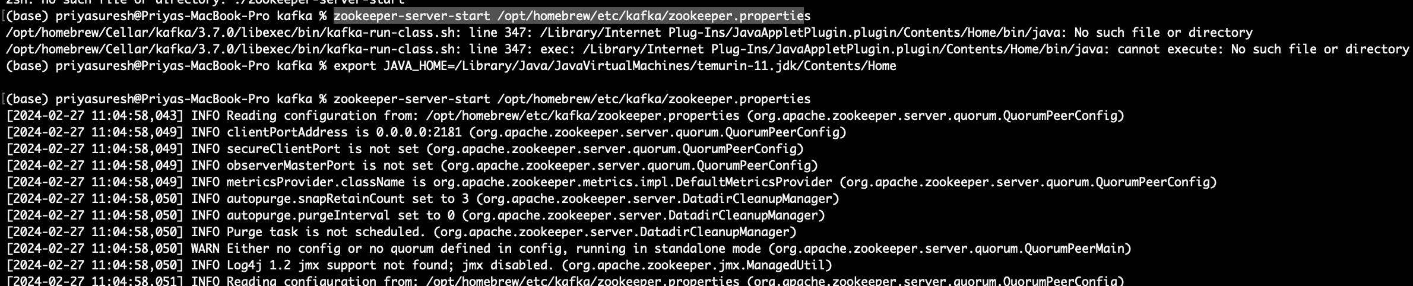

Added the listener in the Kafka properties file :

listeners=PLAINTEXT://localhost:9092

Stopped and restarted the Kafka server:

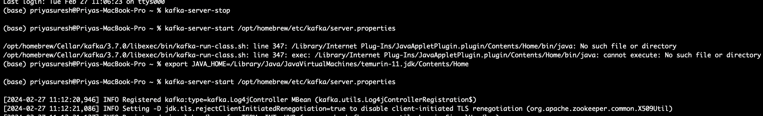

Changed the zookeeper server to start and run in the background process:

zookeeper-server-start -daemon /opt/homebrew/etc/kafka/zookeeper.properties

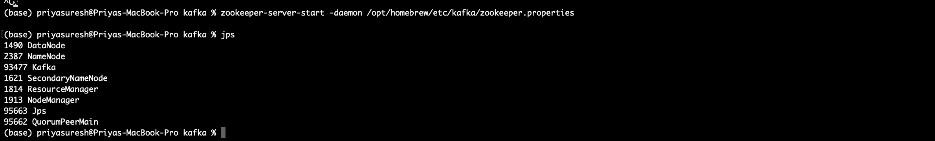

Quorumpeermain is a zookeeper, and Kafka is also running.

Verified by creating a Kafka topic and sending messages from producer to consumer:

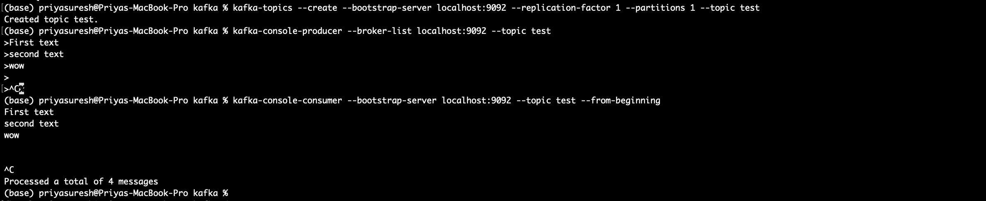

Technical Difficulties:

Installing Kafka and starting background services for Kafka was straightforward. But while starting Zookeeper, the command was struck, and I had to add a daemon in the code to make it run in the background.

Hive Setup:

We have installed Hadoop with HDFS, and it's running in the local system. Now installing hive using brew install hive.

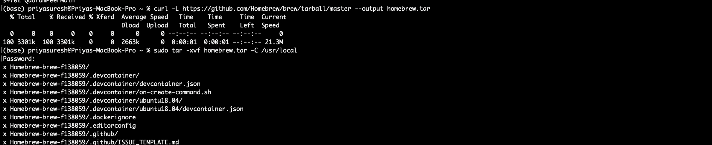

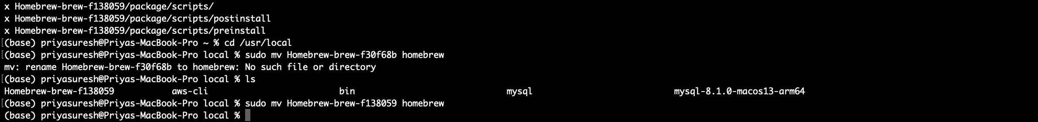



axbrew install hive

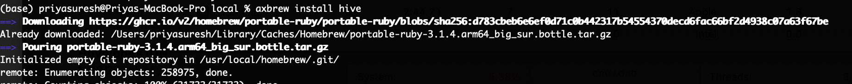

cd /usr/local/homebrew/Cellar/hadoop/3.3.6/libexec/etc/hadoop

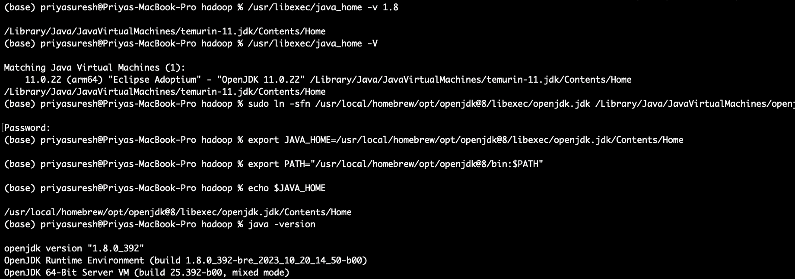



nano hadoop-env.sh

export [JAVA_HOME=/usr/local/homebrew/opt/openjdk@8/libexec/openjdk.jdk/Contents/Home](mailto:JAVA_HOME=/usr/local/homebrew/opt/openjdk@8/libexec/openjdk.jdk/Contents/Home)

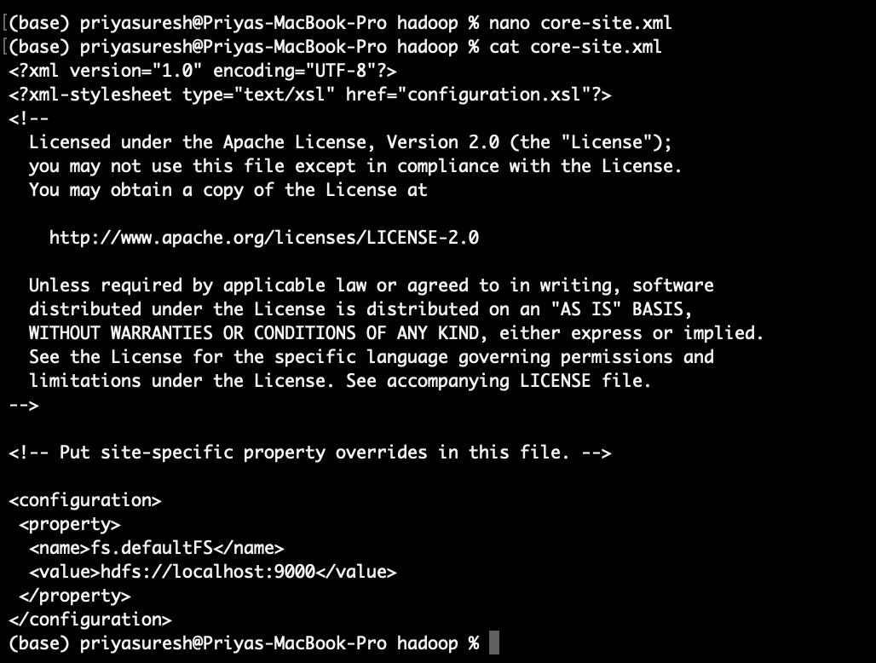

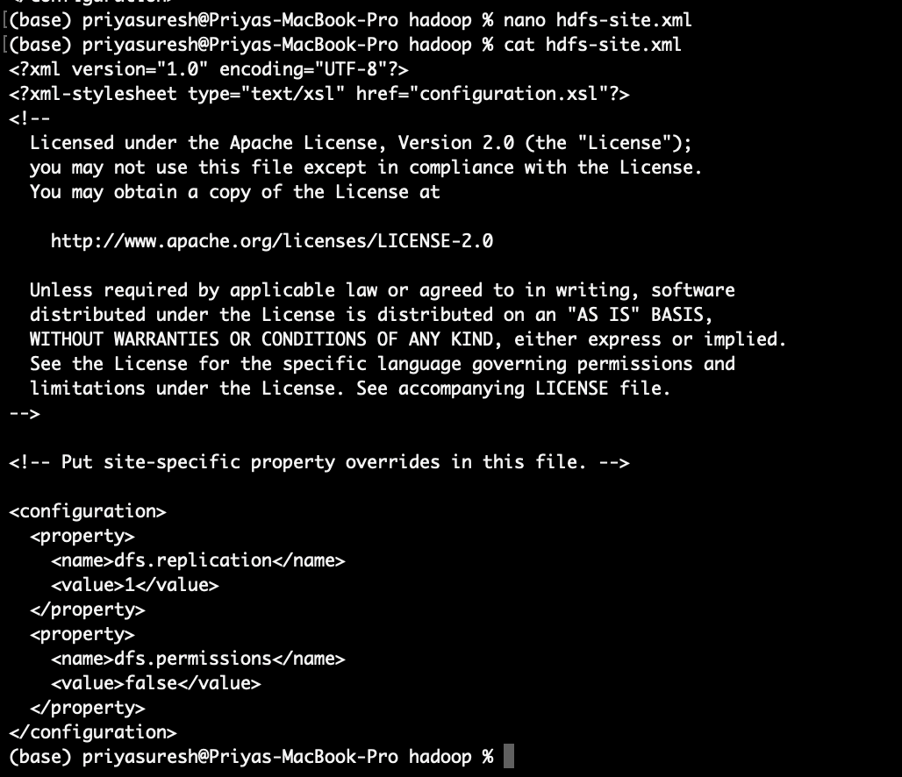

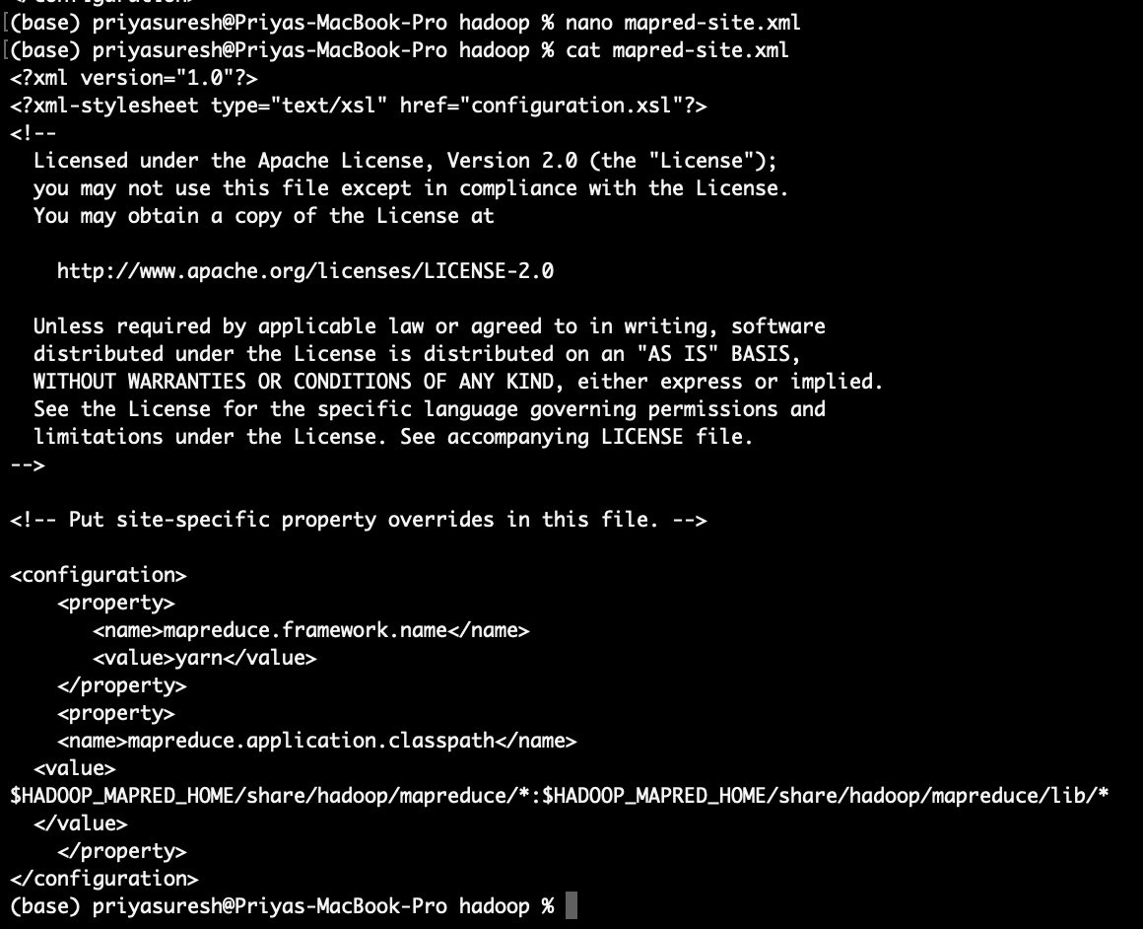

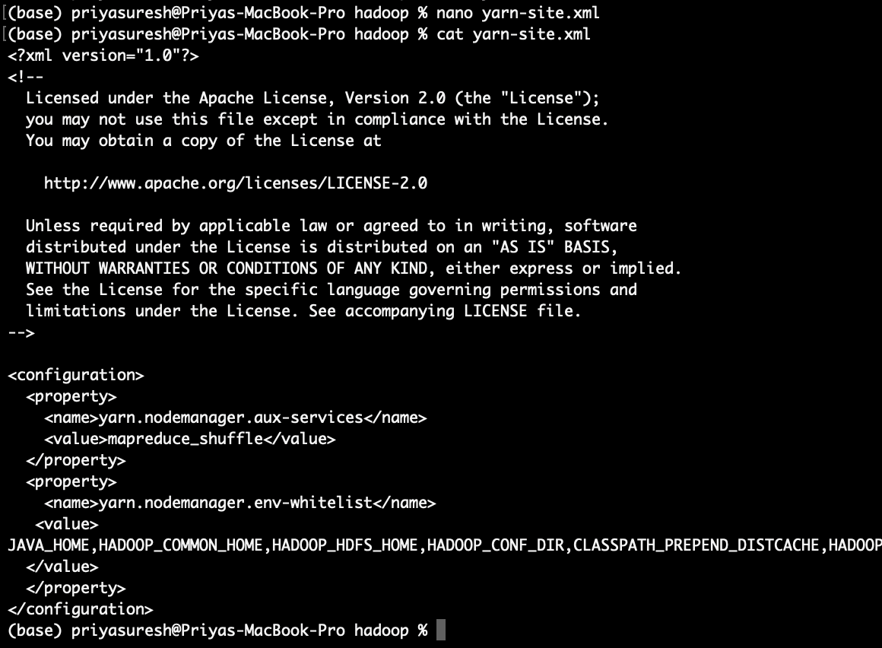

(base) priyasuresh@Priyas-MacBook-Pro hadoop % cat ~/.ssh/id_rsa.pub >> ~/.ssh/authorized_keys

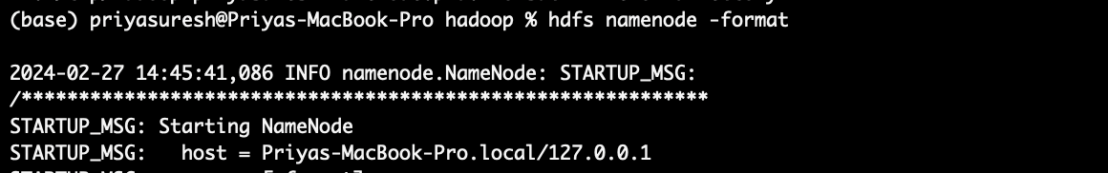

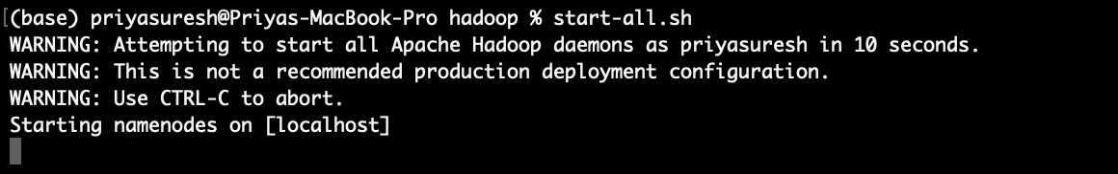

[http://localhost:9870](http://localhost:9870/)

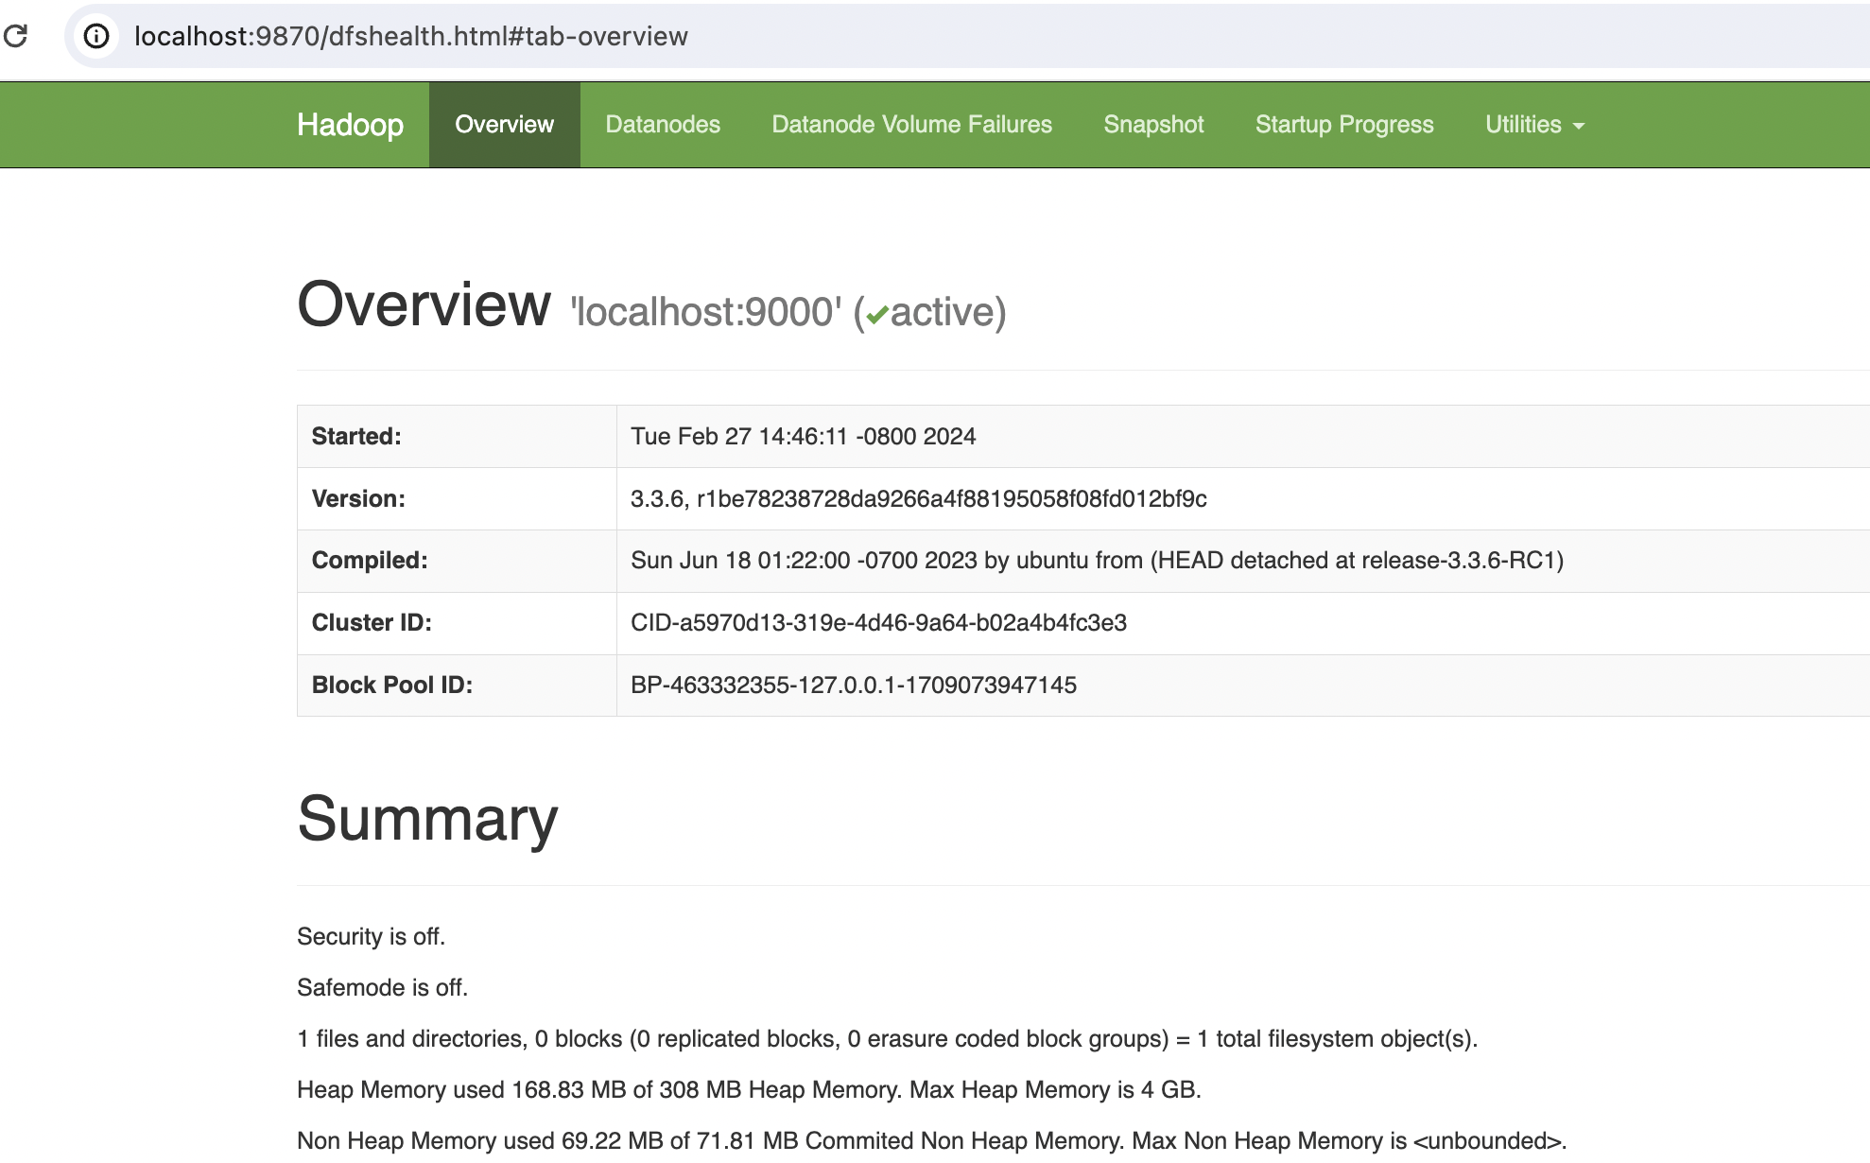

export HIVE_HOME=/usr/local/homebrew/Cellar/hive/3.1.3/libexec  
export PATH=$PATH:/$HIVE_HOME/bin  
  
export HADOOP_OPTS="-Djava.library.path=$HADOOP_INSTALL/lib/native"

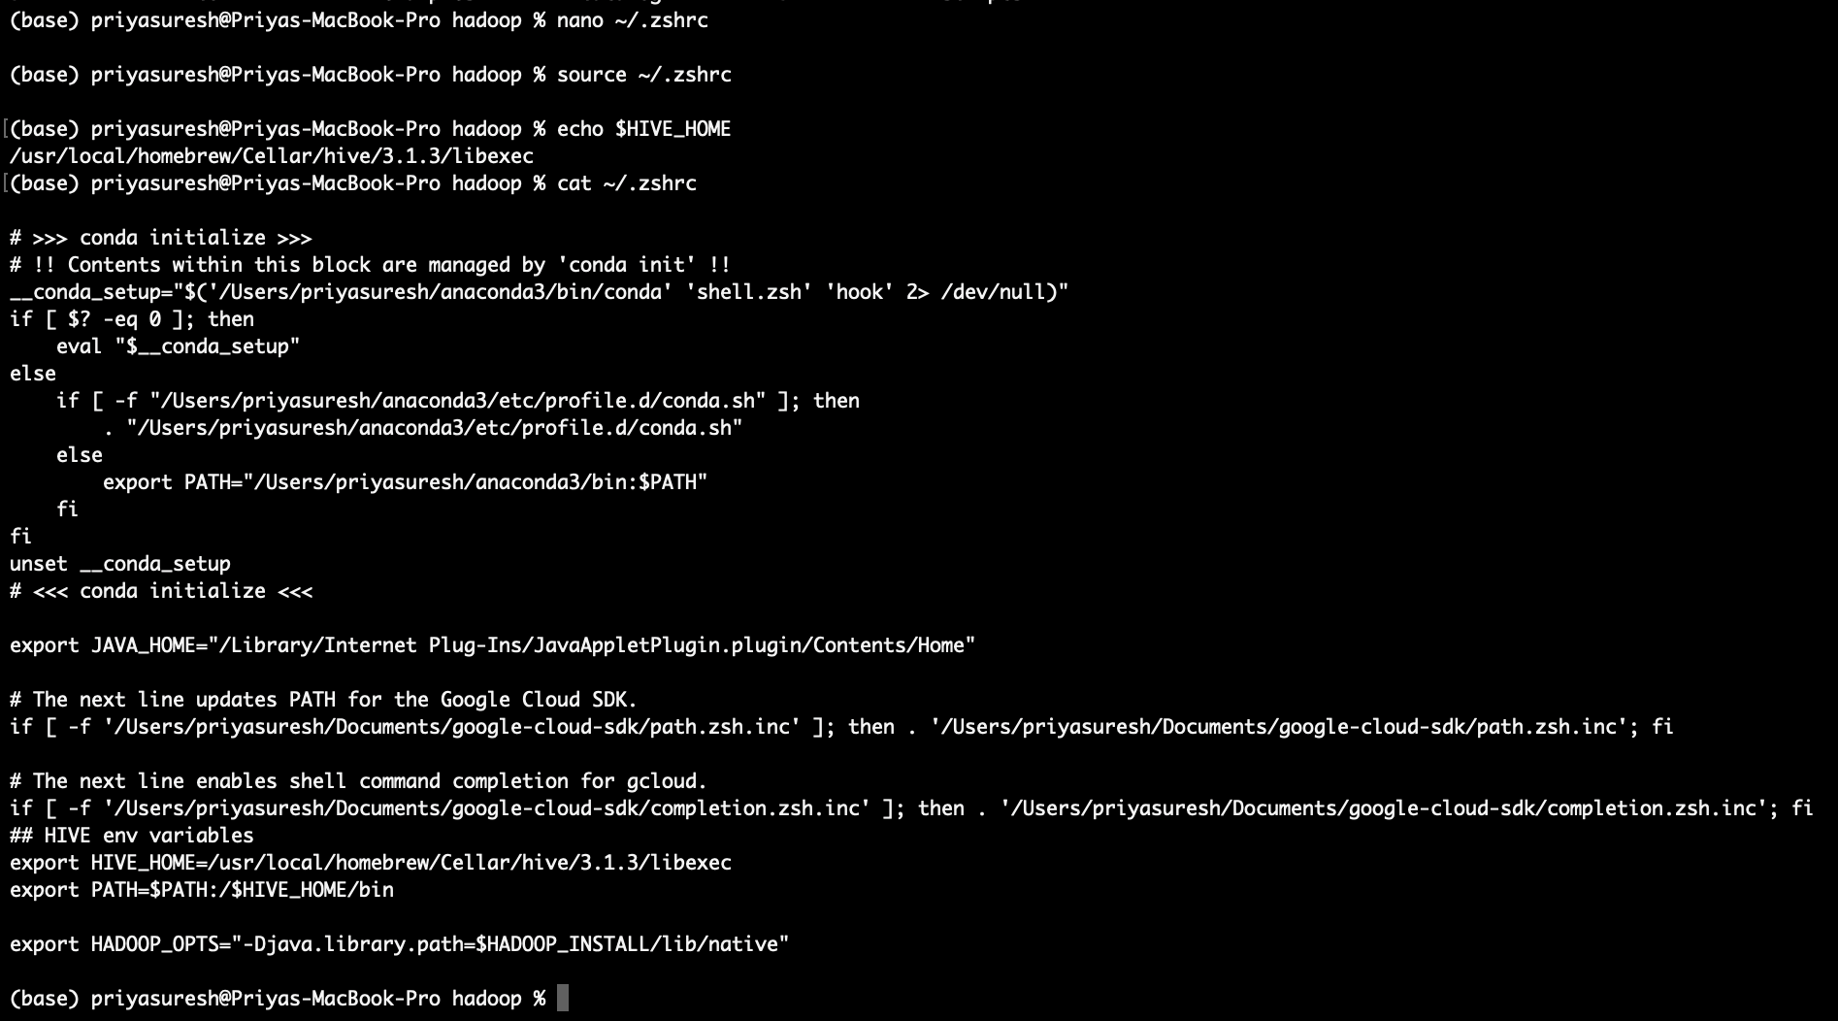

Login to mysql server:

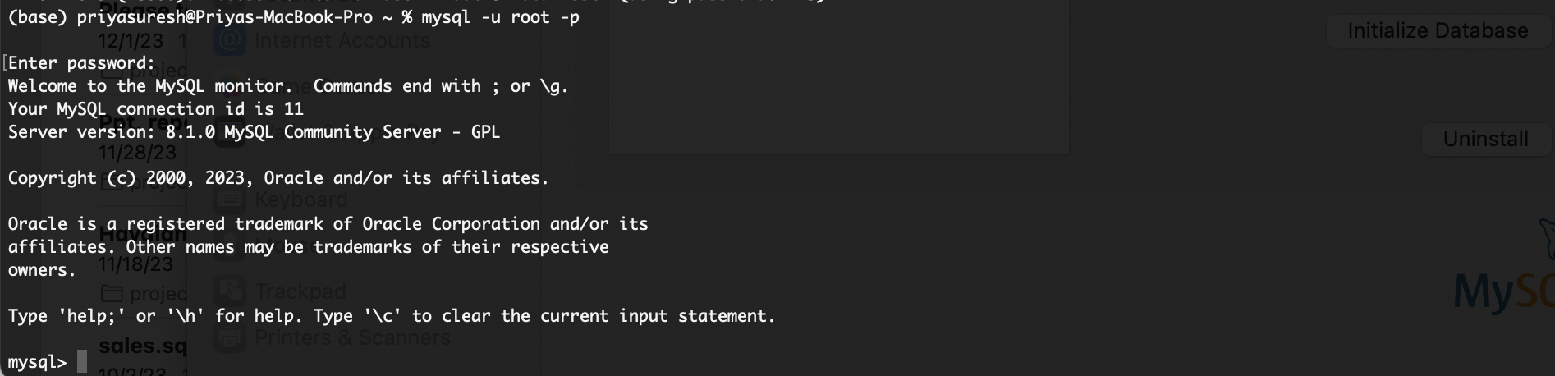

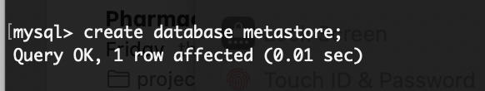

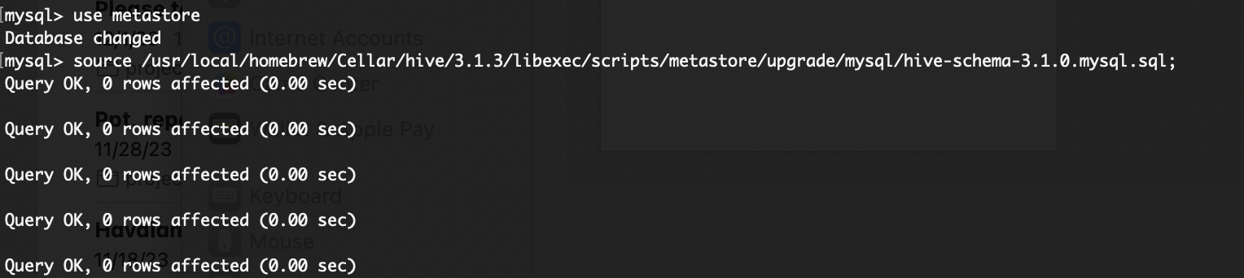

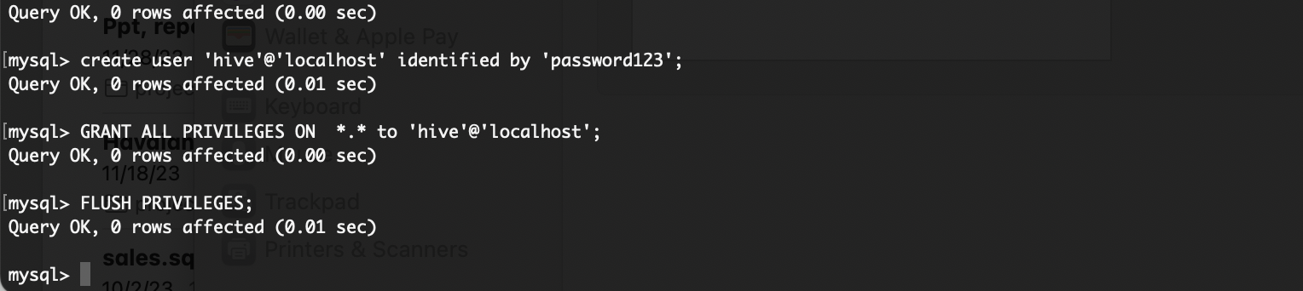

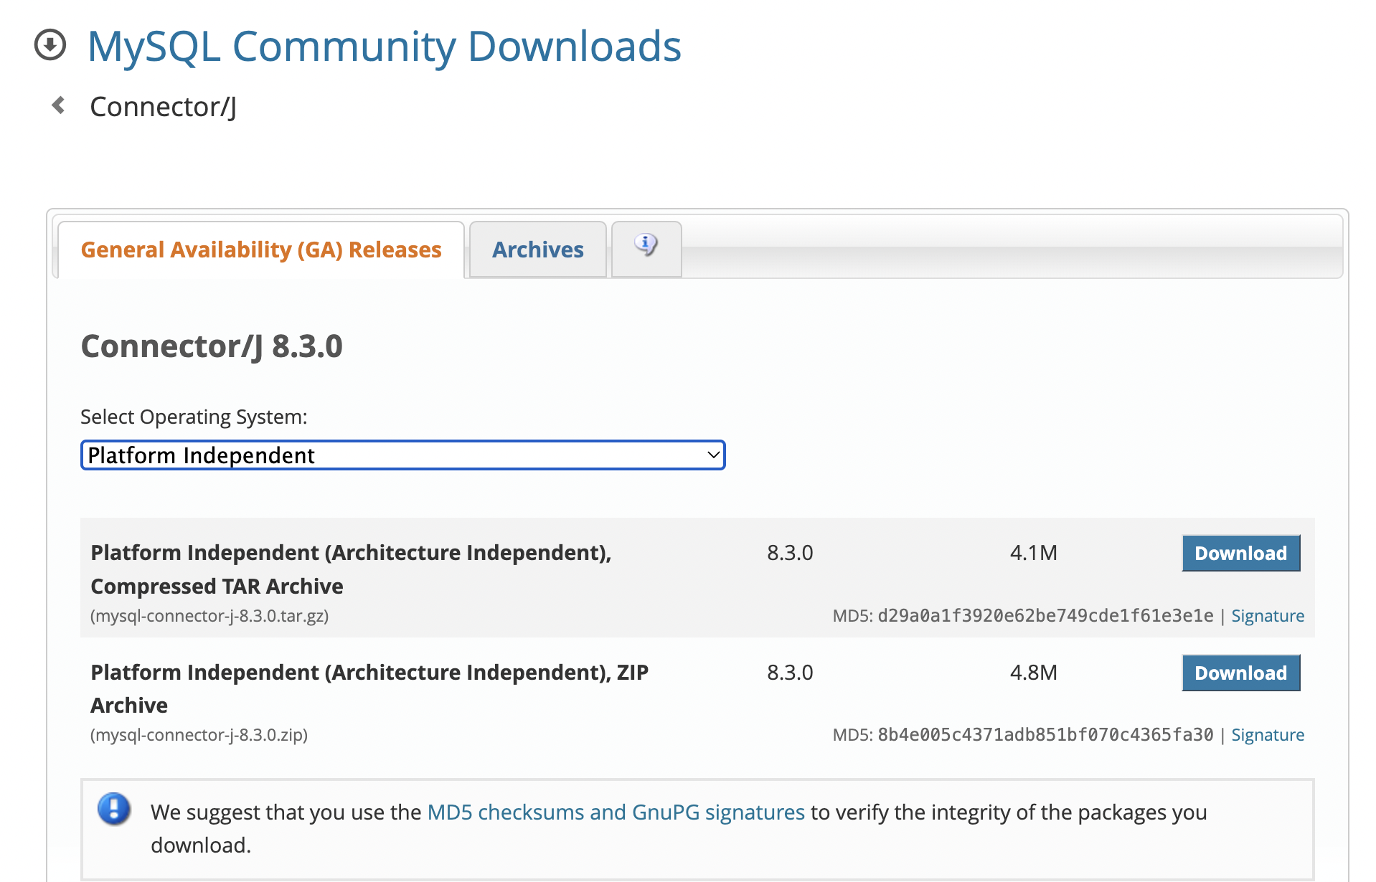

(base) priyasuresh@Priyas-MacBook-Pro Downloads % cp /Users/priyasuresh/Downloads/mysql-connector-j-8.3.0/mysql-connector-j-8.3.0.jar /usr/local/homebrew/Cellar/hive/3.1.3/libexec/lib/

(base) priyasuresh@Priyas-MacBook-Pro Downloads %

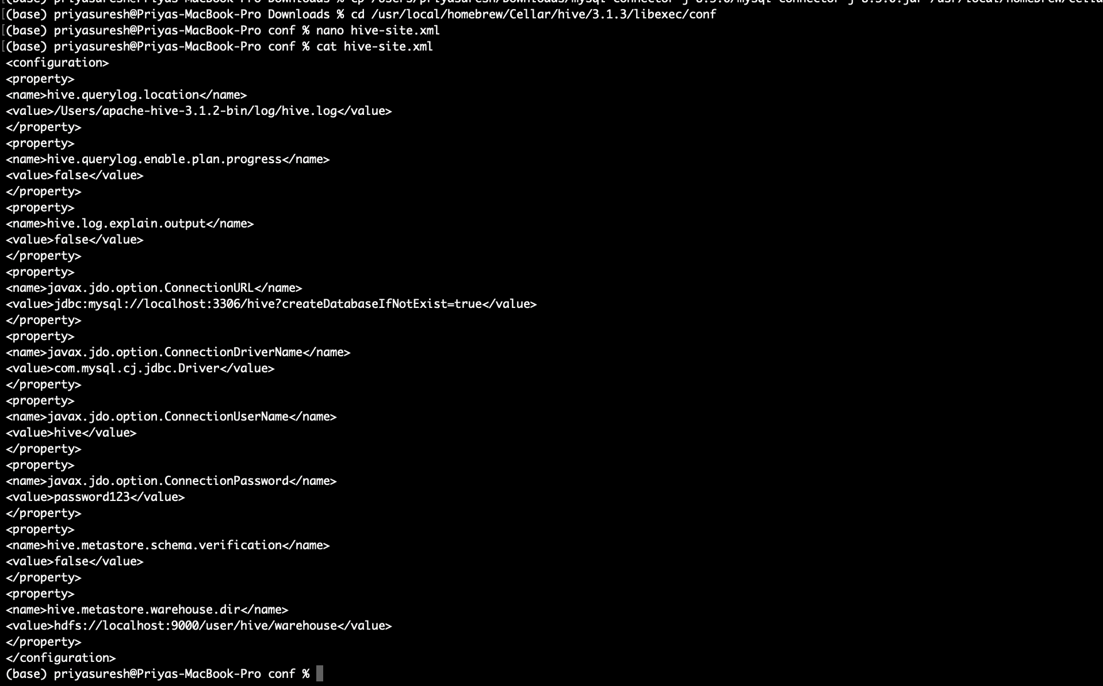

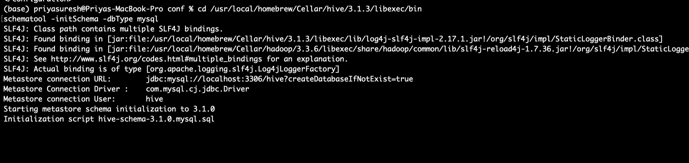

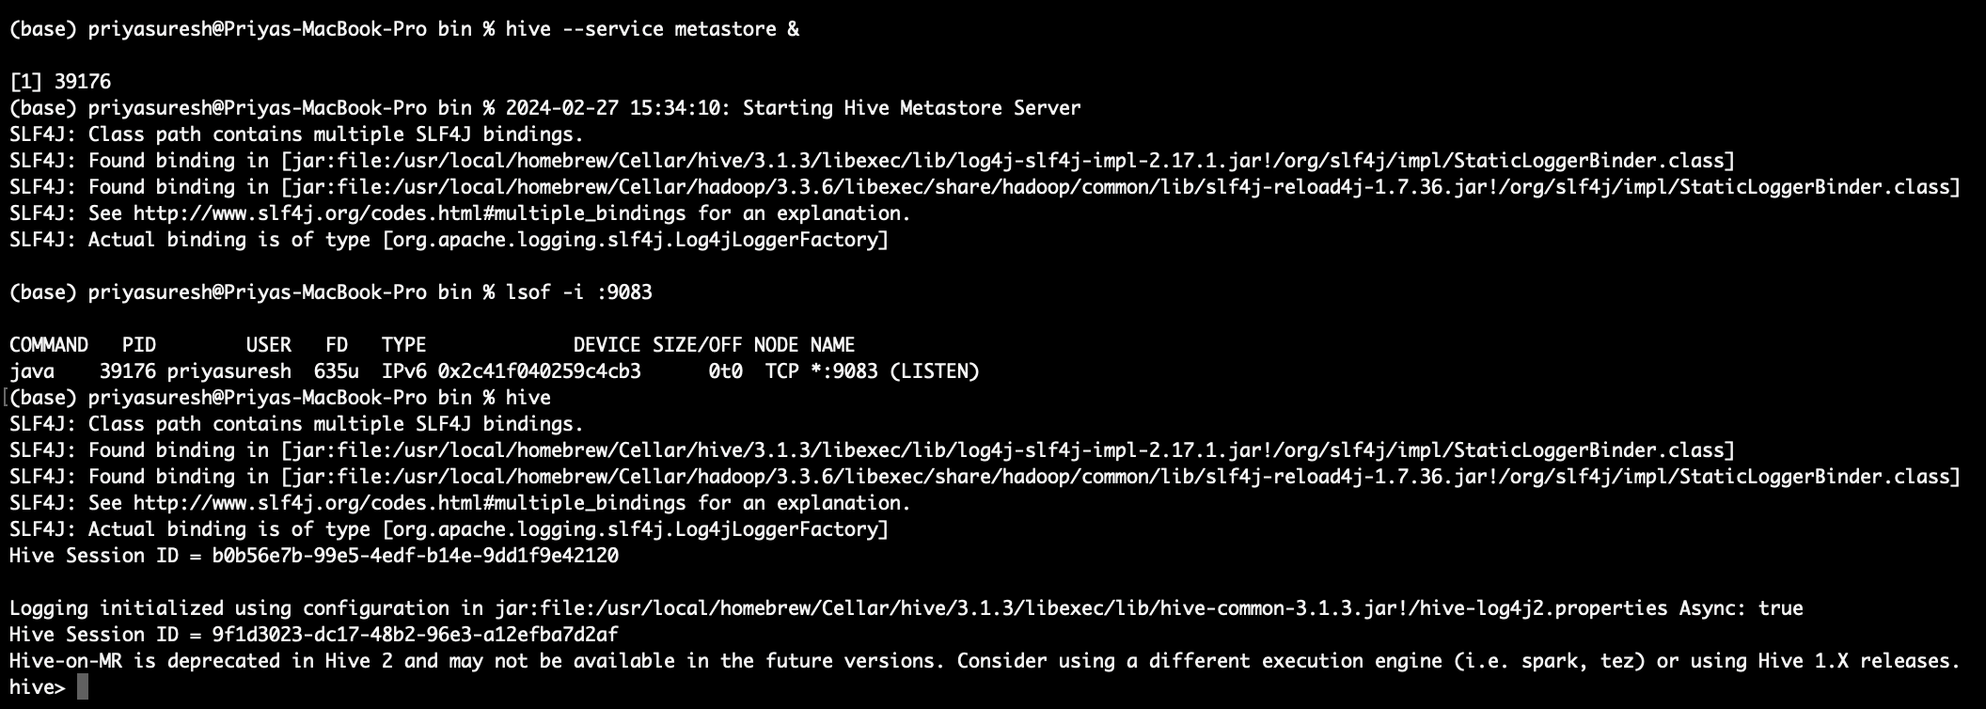

base) priyasuresh@Priyas-MacBook-Pro sbin % jps

25601 Kafka

7650 ResourceManager

26722 QuorumPeerMain

26723 Jps

23491 DataNode

23387 NameNode

8125 NodeManager

23630 SecondaryNameNode

To start Hive:

(base) priyasuresh@Priyas-MacBook-Pro ~ % source ~/.zshrc

(base) priyasuresh@Priyas-MacBook-Pro ~ % hive

SLF4J: Class path contains multiple SLF4J bindings.

SLF4J: Found binding in [jar:file:/usr/local/homebrew/Cellar/hive/3.1.3/libexec/lib/log4j-slf4j-impl-2.17.1.jar!/org/slf4j/impl/StaticLoggerBinder.class]

SLF4J: Found binding in [jar:file:/usr/local/homebrew/Cellar/hadoop/3.3.6/libexec/share/hadoop/common/lib/slf4j-reload4j-1.7.36.jar!/org/slf4j/impl/StaticLoggerBinder.class]

SLF4J: See http://www.slf4j.org/codes.html#multiple_bindings for an explanation.

SLF4J: Actual binding is of type [org.apache.logging.slf4j.Log4jLoggerFactory]

Hive Session ID = 93035400-c826-4bd3-858e-c637537f5106

Logging initialized using configuration in jar:file:/usr/local/homebrew/Cellar/hive/3.1.3/libexec/lib/hive-common-3.1.3.jar!/hive-log4j2.properties Async: true

Hive Session ID = 17a246f3-91c2-490f-b750-1134f181abad

Hive-on-MR is deprecated in Hive 2 and may not be available in the future versions. Consider using a different execution engine (i.e. spark, tez) or using Hive 1.X releases.

hive>

Pyspark Setup:

Checking my current python version and installing pyspark:

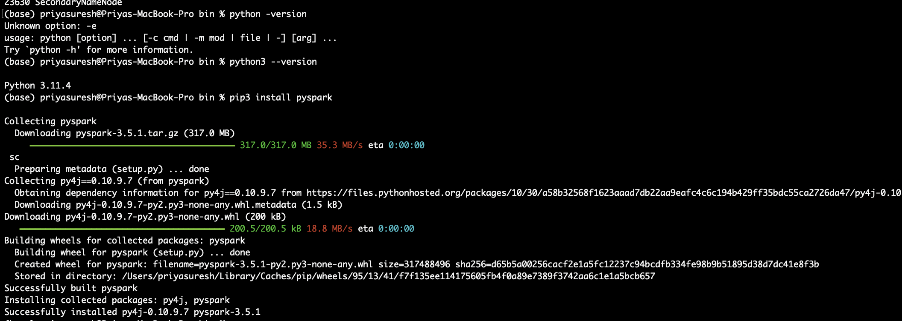

Installing Kafka Python to connect to kafka from python:

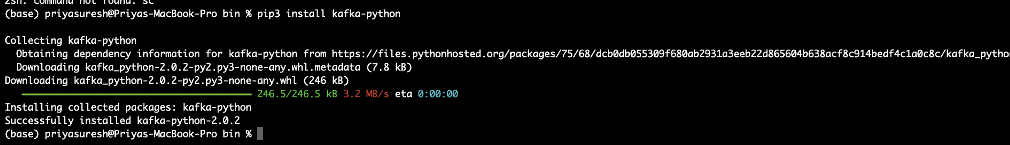

Created hdfs new directory:

(base) priyasuresh@Priyas-MacBook-Pro bin % hdfs dfs -mkdir -p hdfs://localhost:9000/user/priyasuresh/

2024-02-28 18:25:28,530 WARN util.NativeCodeLoader: Unable to load native-hadoop library for your platform... using builtin-java classes where applicable

(base) priyasuresh@Priyas-MacBook-Pro bin % hdfs dfs -ls hdfs://localhost:9000/user/priyasuresh/

2024-02-28 18:25:45,318 WARN util.NativeCodeLoader: Unable to load native-hadoop library for your platform... using builtin-java classes where applicable

(base) priyasuresh@Priyas-MacBook-Pro bin %

(base) priyasuresh@Priyas-MacBook-Pro kafka % hdfs dfs -chmod 777 /user/priyasuresh/

2024-02-28 20:04:58,991 WARN util.NativeCodeLoader: Unable to load native-hadoop library for your platform... using builtin-java classes where applicable

(base) priyasuresh@Priyas-MacBook-Pro kafka %

Verified kafka in Jupyter notebook:

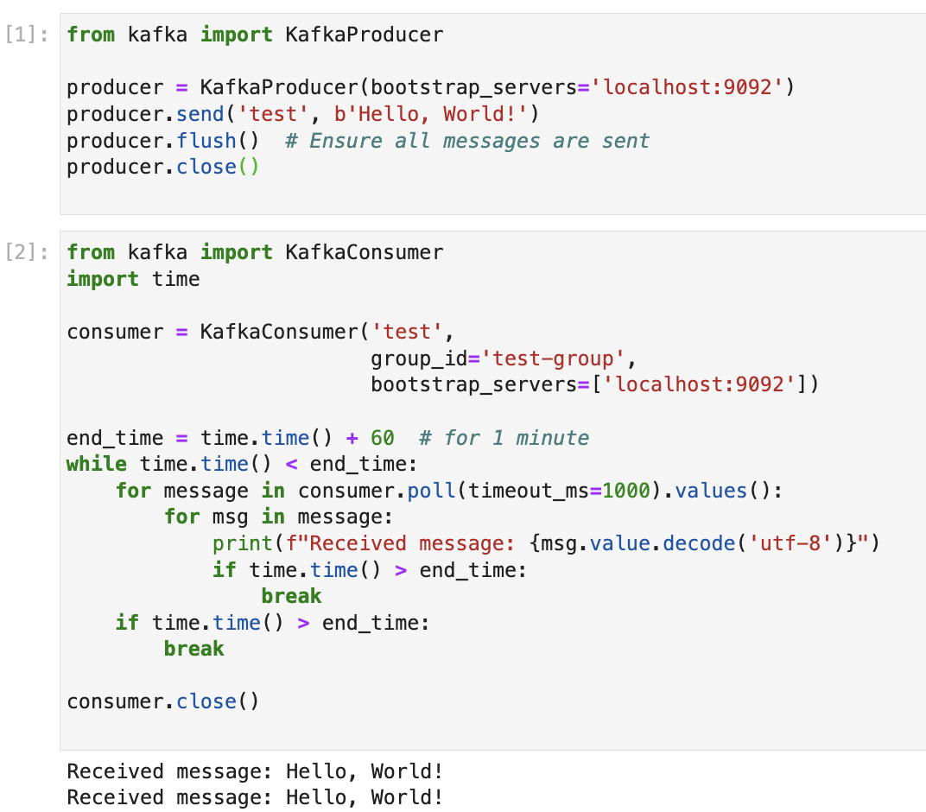

Verified spark and kafka configuration for streaming queries:

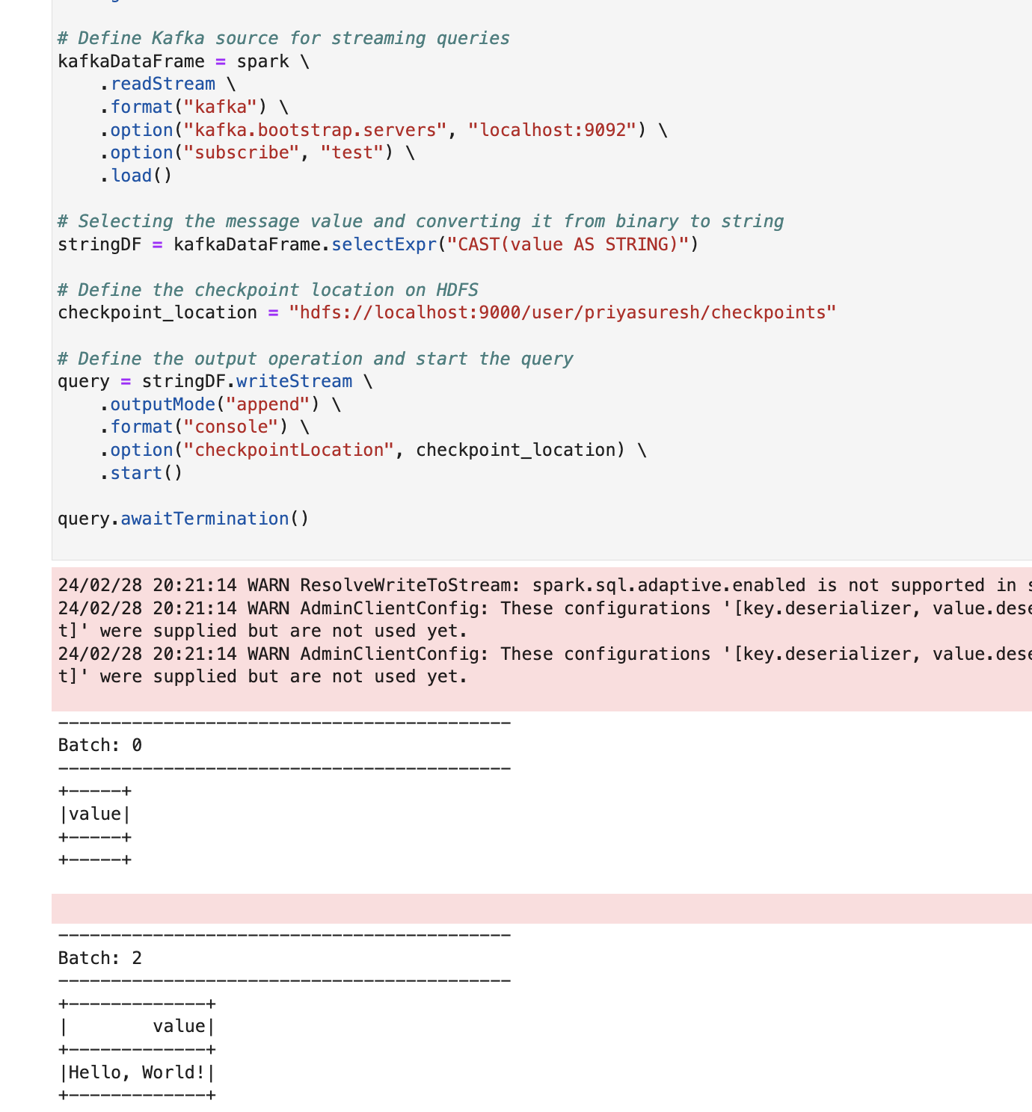

3.1. c) API keys generation:

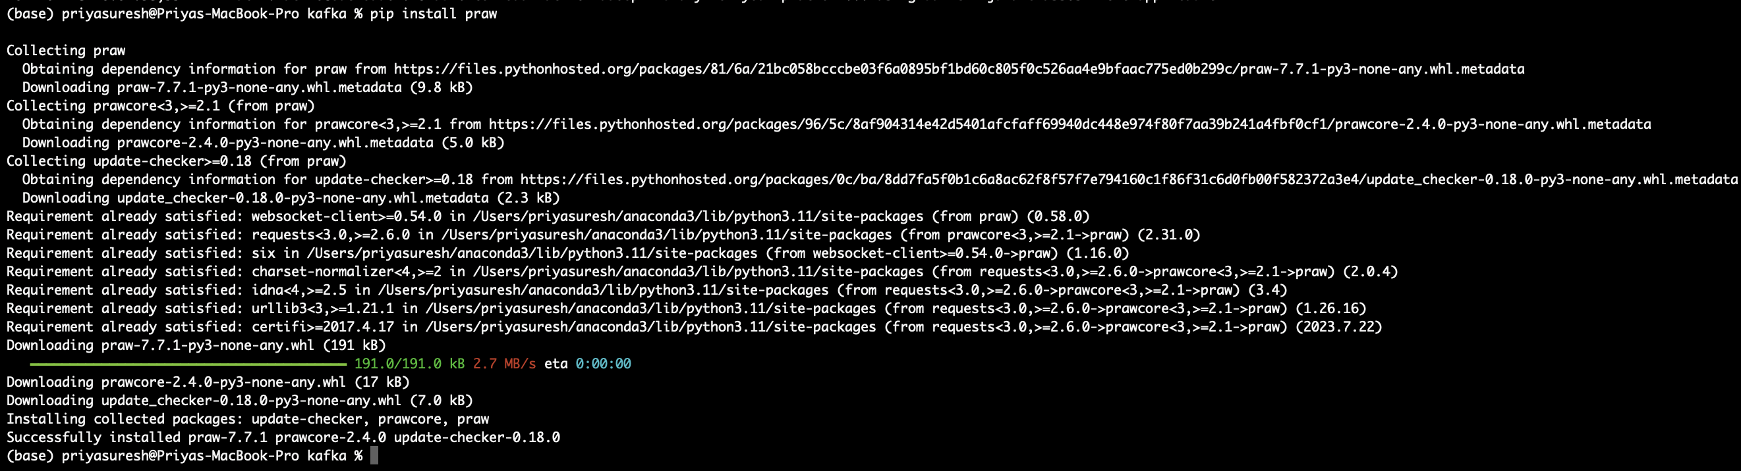

Created API keys in reddit by creating new account, app developer and verified the connection in python:

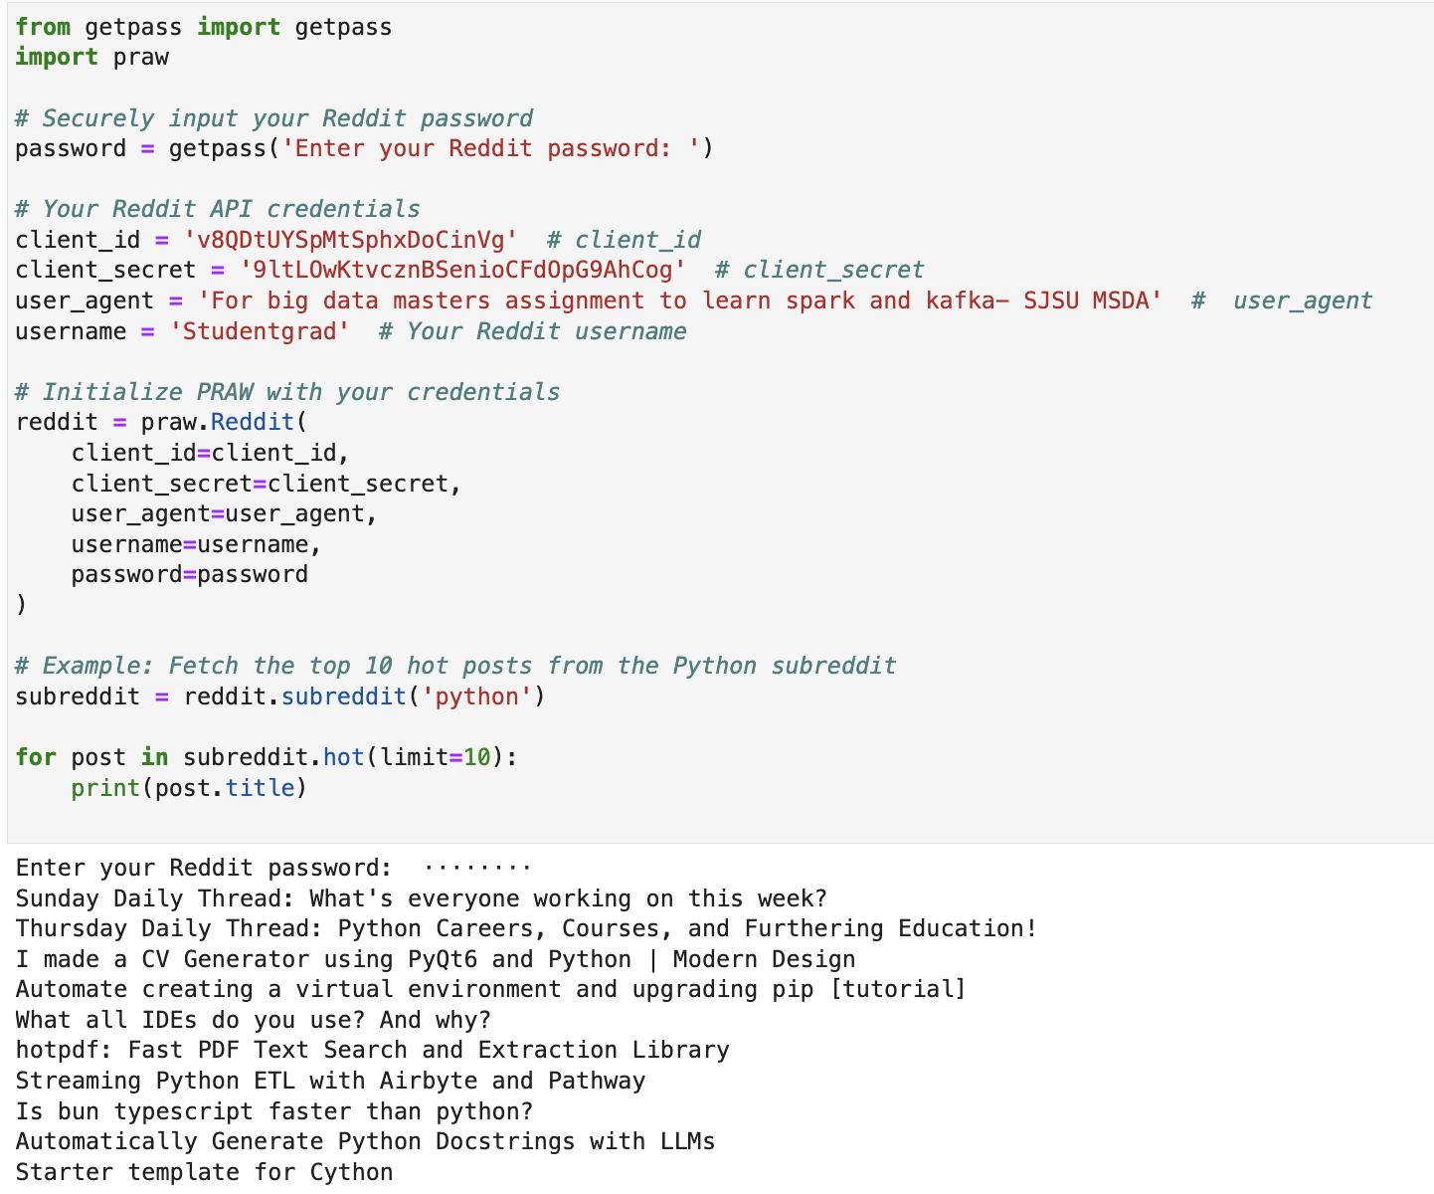

3.2. a) Python script for real-time streaming consumer:

Cd /opt/homebrew/Cellar/kafka/3.7.0/bin

**Creating new Kafka topics:**

(base) priyasuresh@Priyas-MacBook-Pro bin % **kafka-topics --create --bootstrap-server localhost:9092 --replication-factor 1 --partitions 1 --topic redditposts**

Created topic redditposts.

(base) priyasuresh@Priyas-MacBook-Pro bin % **kafka-topics --create --bootstrap-server localhost:9092 --replication-factor 1 --partitions 1 --topic reddit**

Created topic reddit.

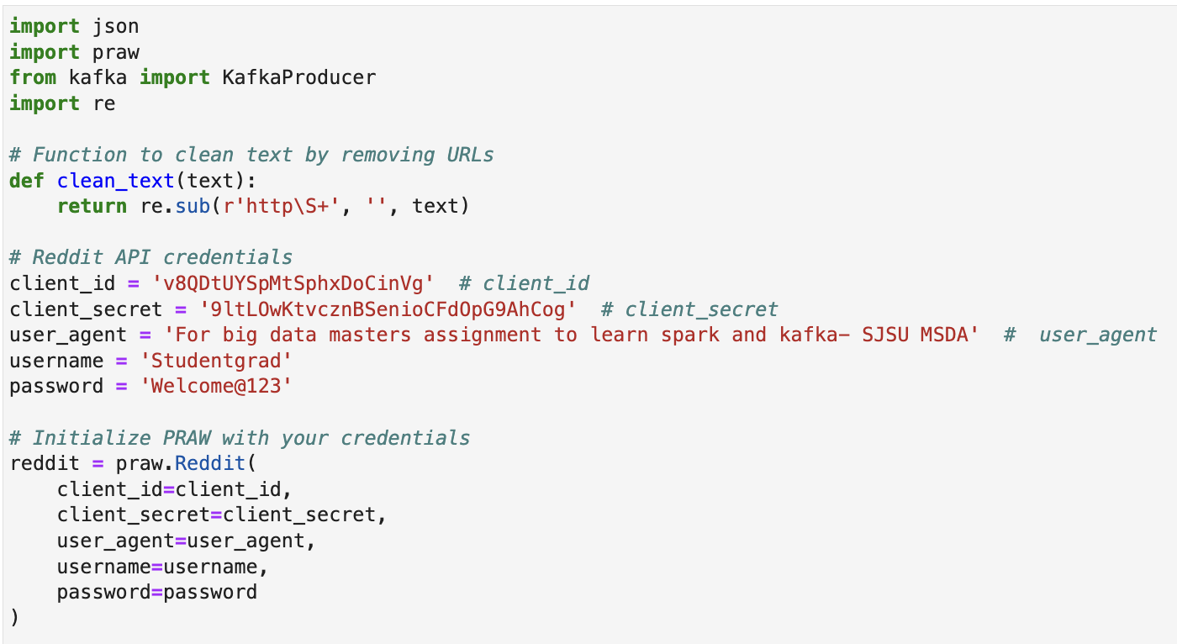

Data is preprocessed and sent to the Kafka topic Reddit:

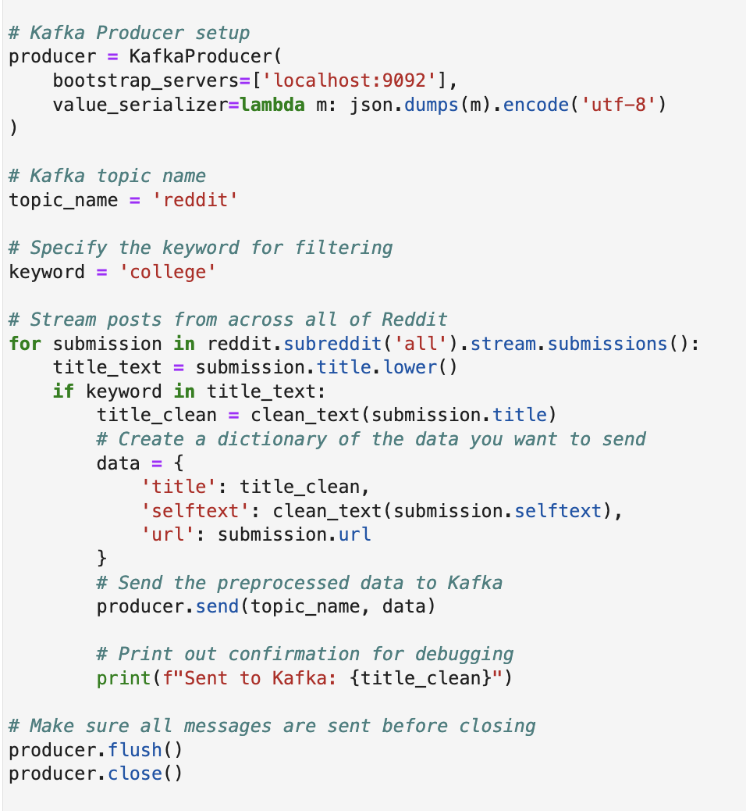

Output:

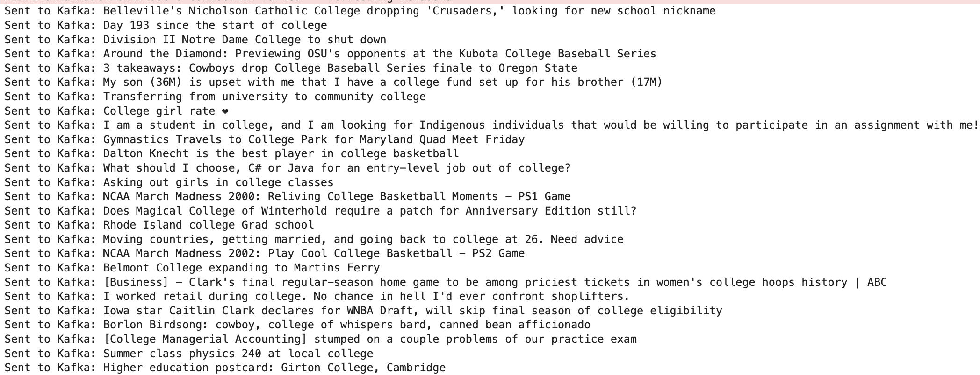

Created Consumer as well for Kafka:

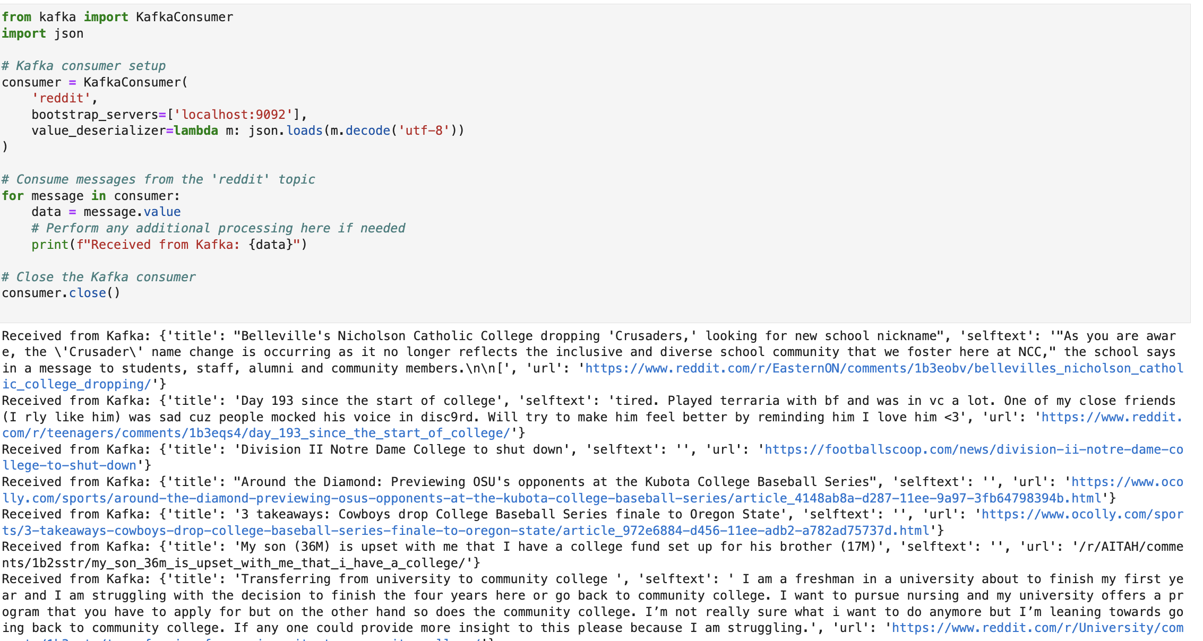

3.2.b) Sentiment Analysis with Spark:

Vader- checking the installation:

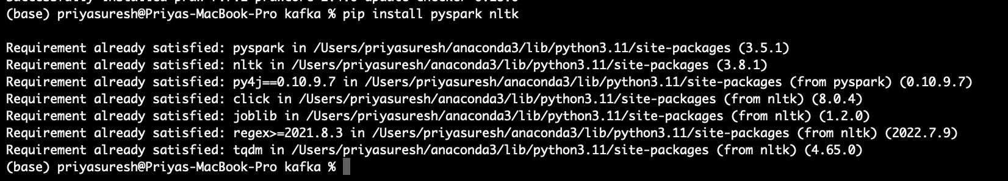

Initializing spark session:

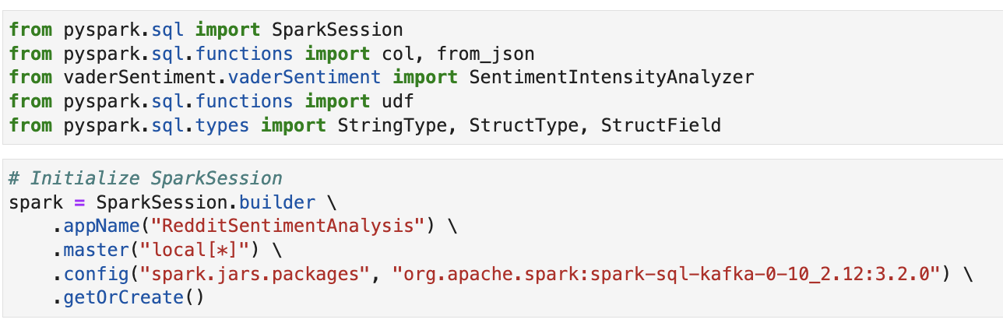

Defining Kafka for streaming, Schema for JSON data and converting JSON to data frame format:

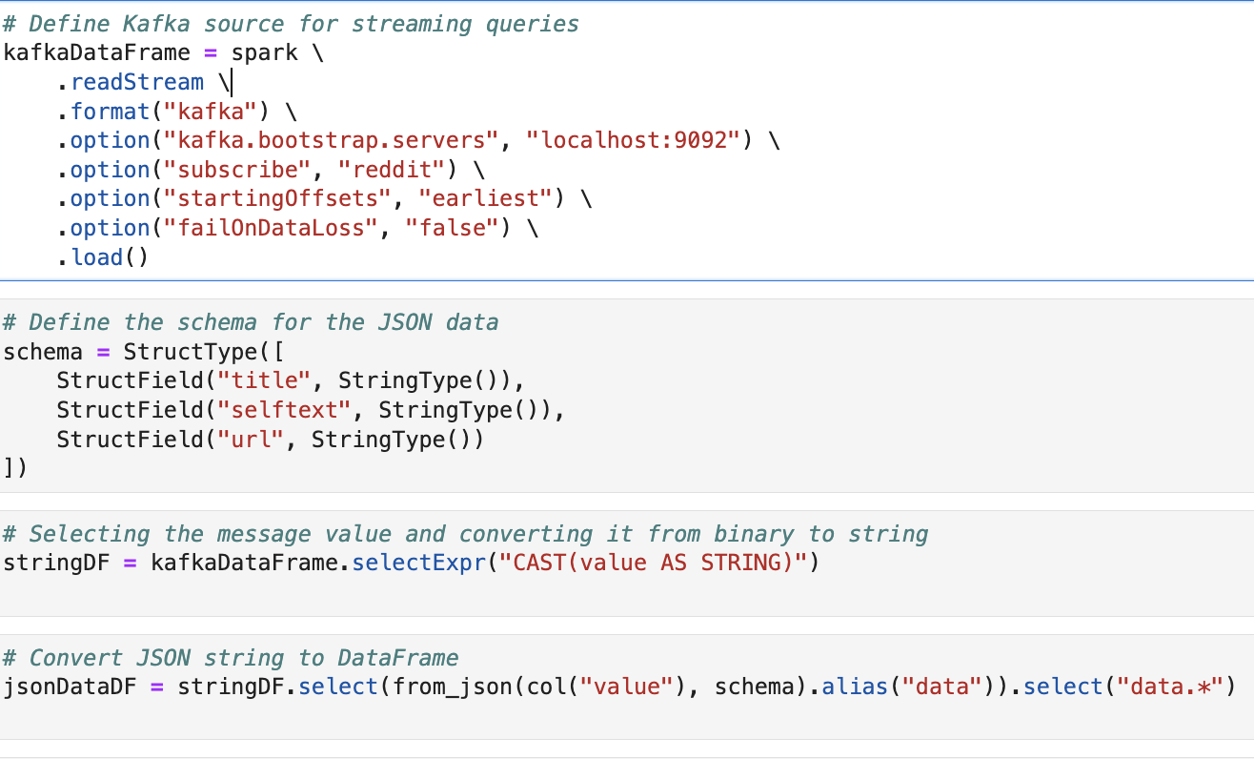

Sentiment analysis using vader:

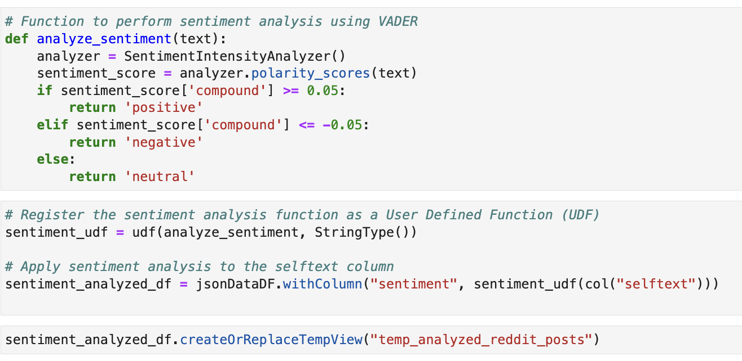

Storing in Hive Table Parquet Format:

Creating a table in hive with HDFS filesystem to store analyzed data:

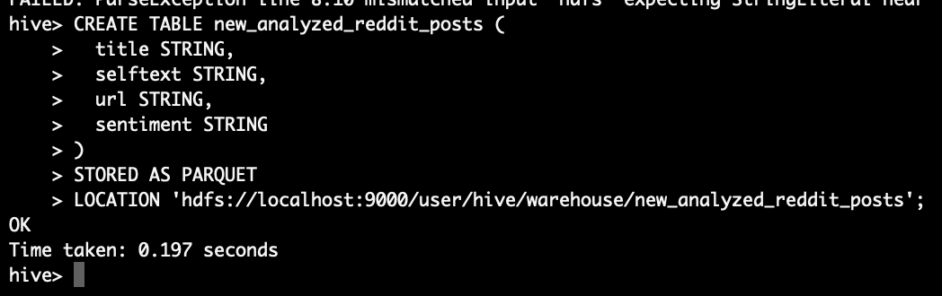

Sending the sentiment analyzed data to hive in parquet format and stored in HDFS:

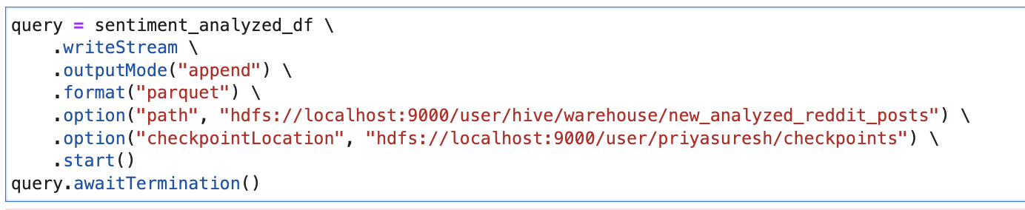

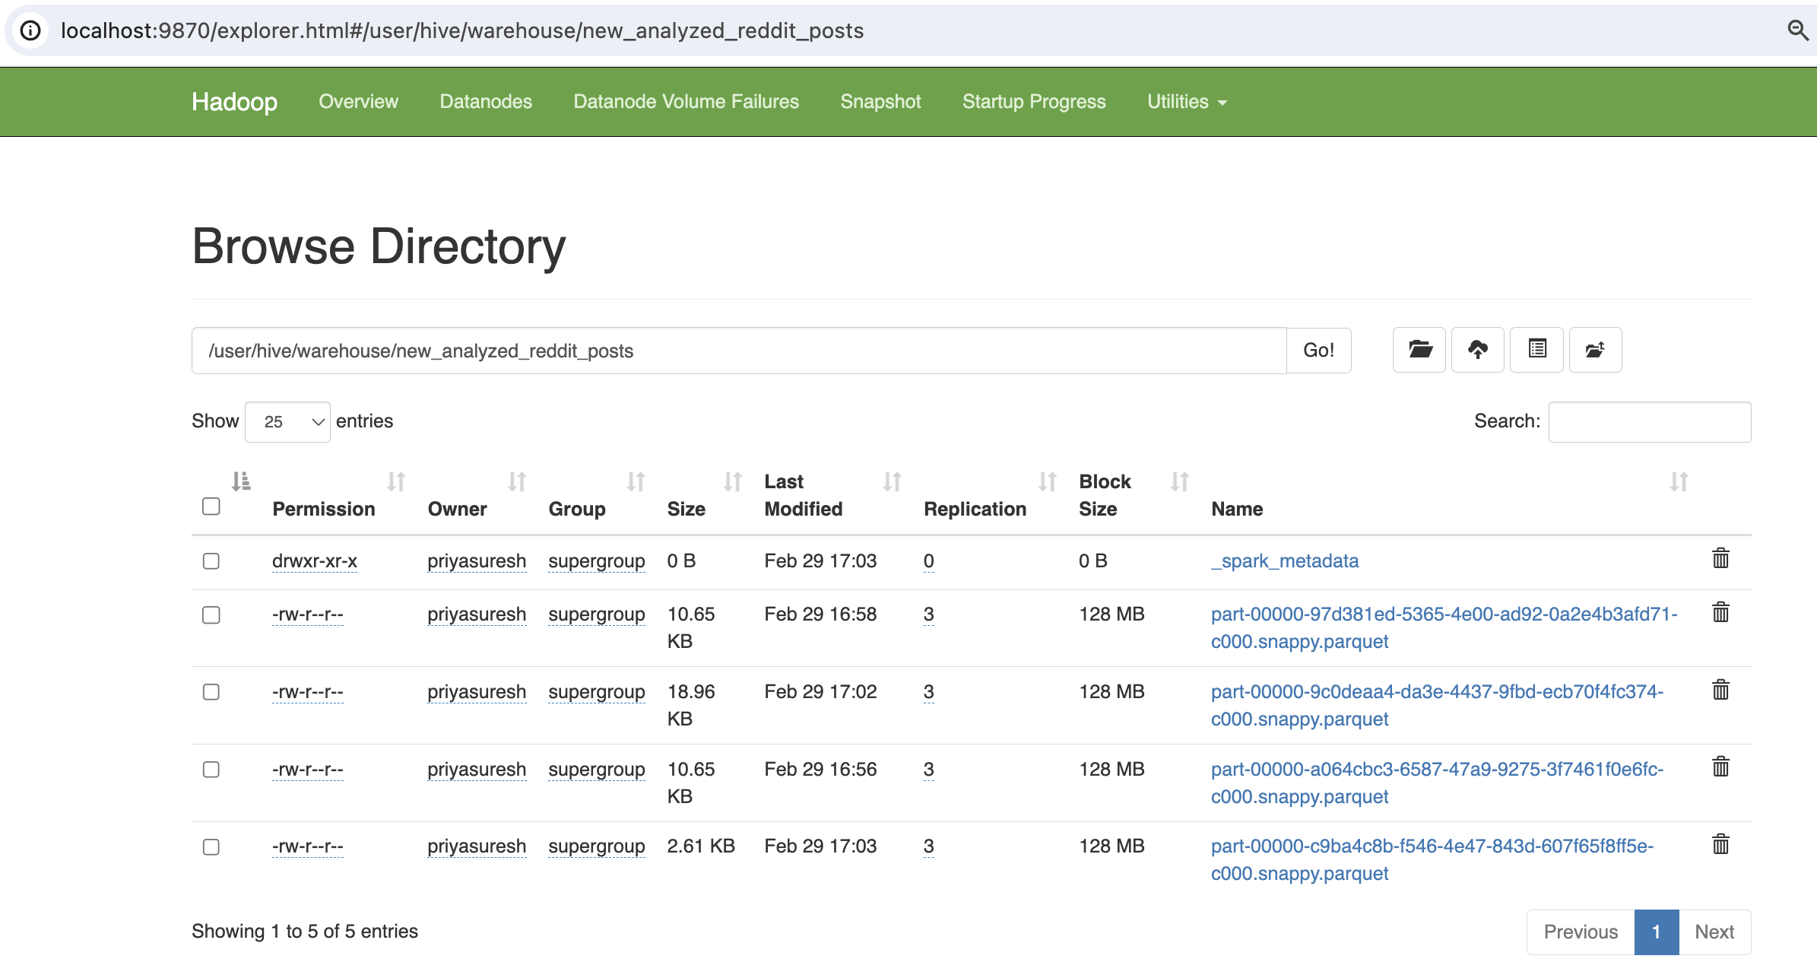

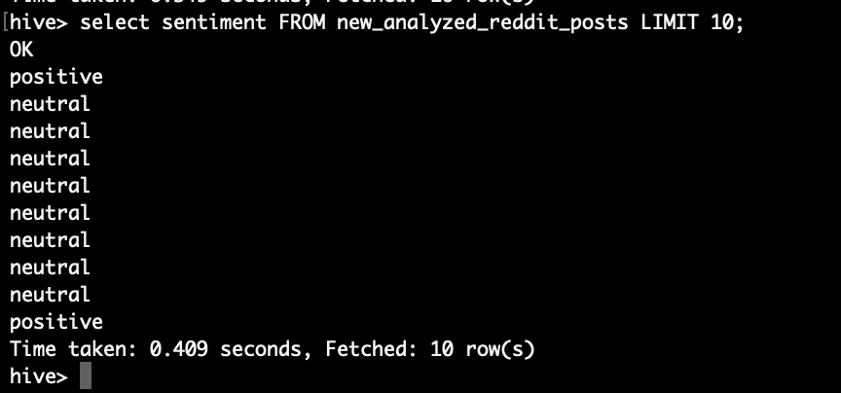

Grafana Setup:

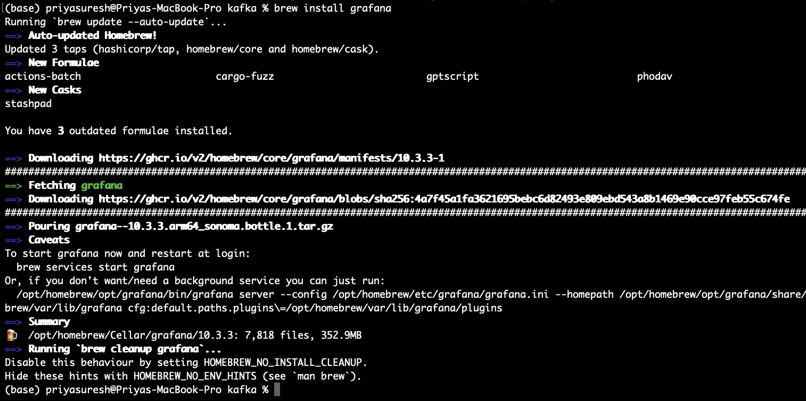

/opt/homebrew/Cellar/grafana/10.3.3

To open:

<http://localhost:3000>

Username: admin

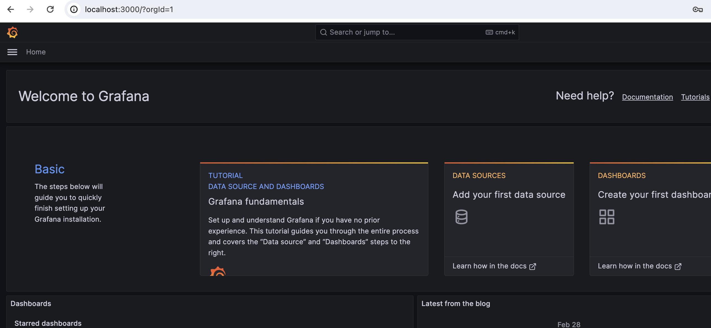

Creating Influx DB to connect with Grafana- hive connection had issues and it is not supported by Grafana.

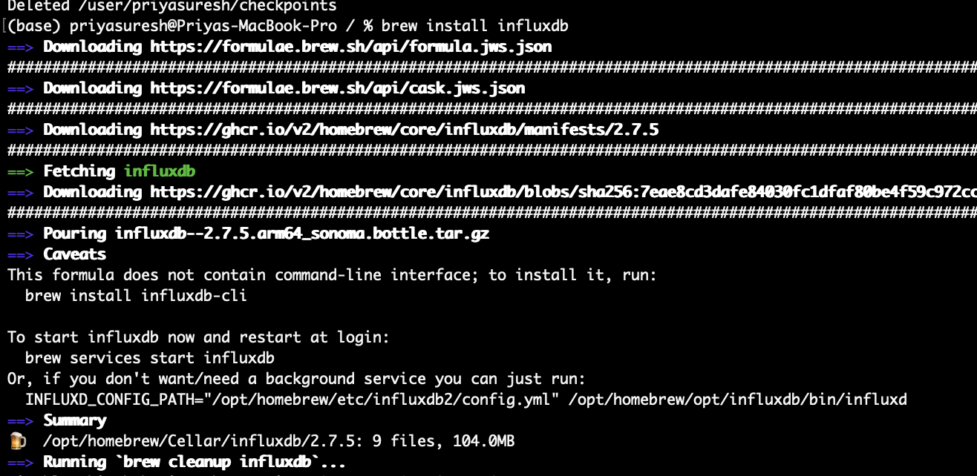

brew services start influxdb

brew install influxdb-cli

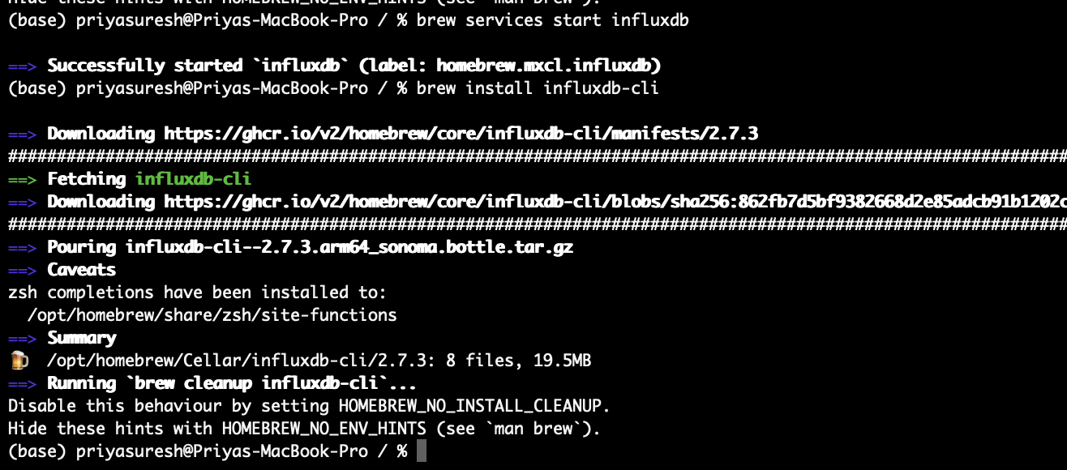

[**http://localhost:8086**](http://localhost:8086)

**(base) priyasuresh@Priyas-MacBook-Pro ~ % influx config set --config-name onboarding \ --host-url "http://localhost:8086" \ --org "sjsu" \ --token "IMxN_tN7fYgjv6yoiqrND0De1RqIOntosy9P8n-bE5NXqUibC9Cx3gWgSWnfyYIzmuwZkMJ9pEdMmVypGdtAeg=="**

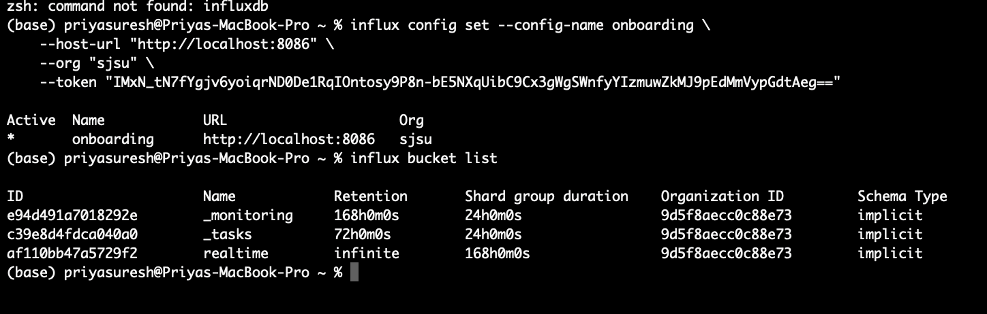

Adding influx db in Grafana as data source:

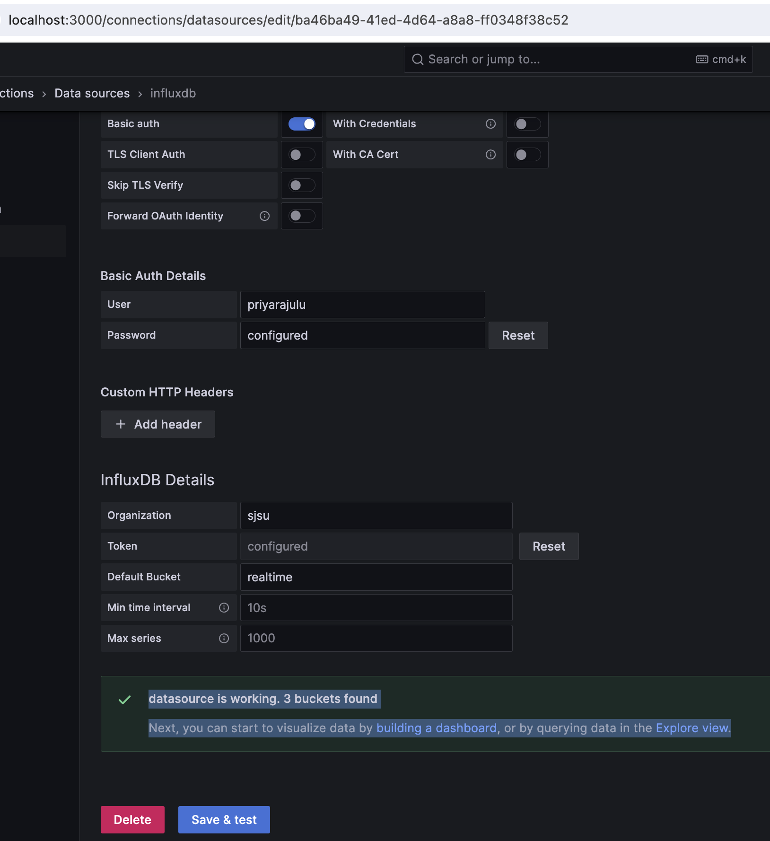

Connecting to influx db from python:

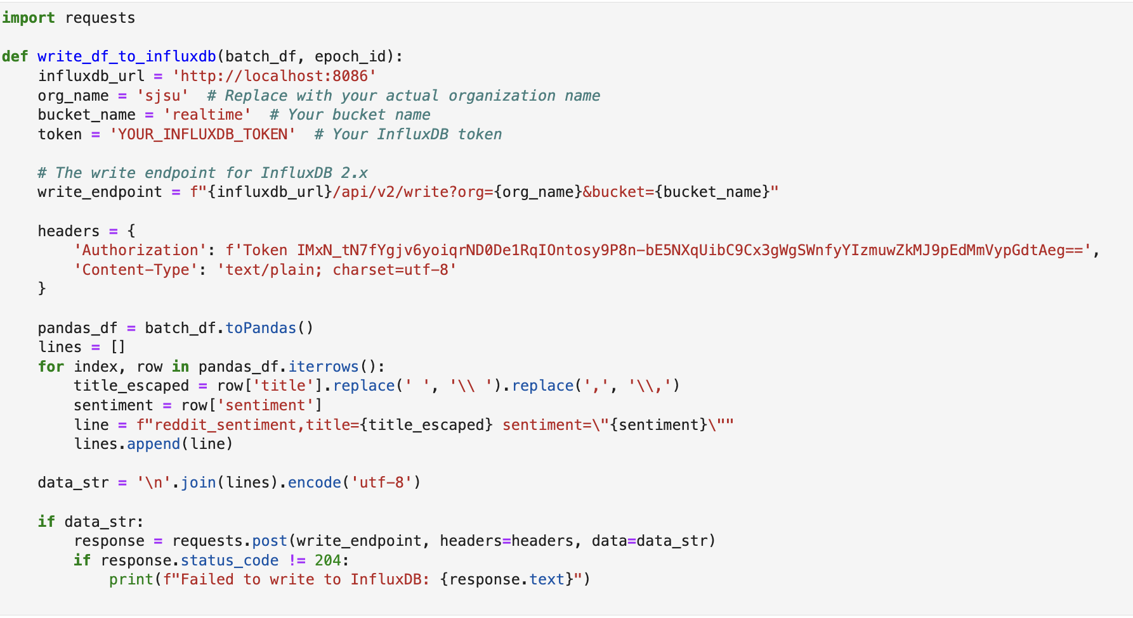

Loading data into influx db from kafka topic:

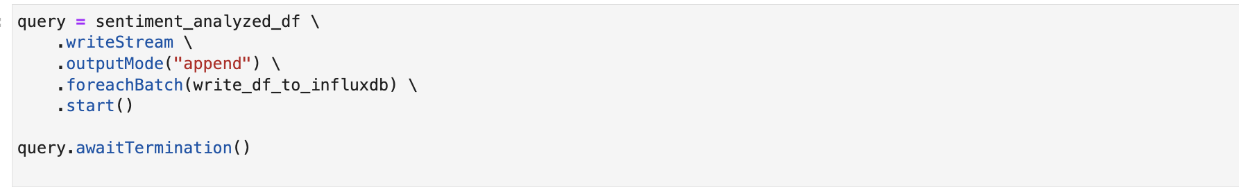

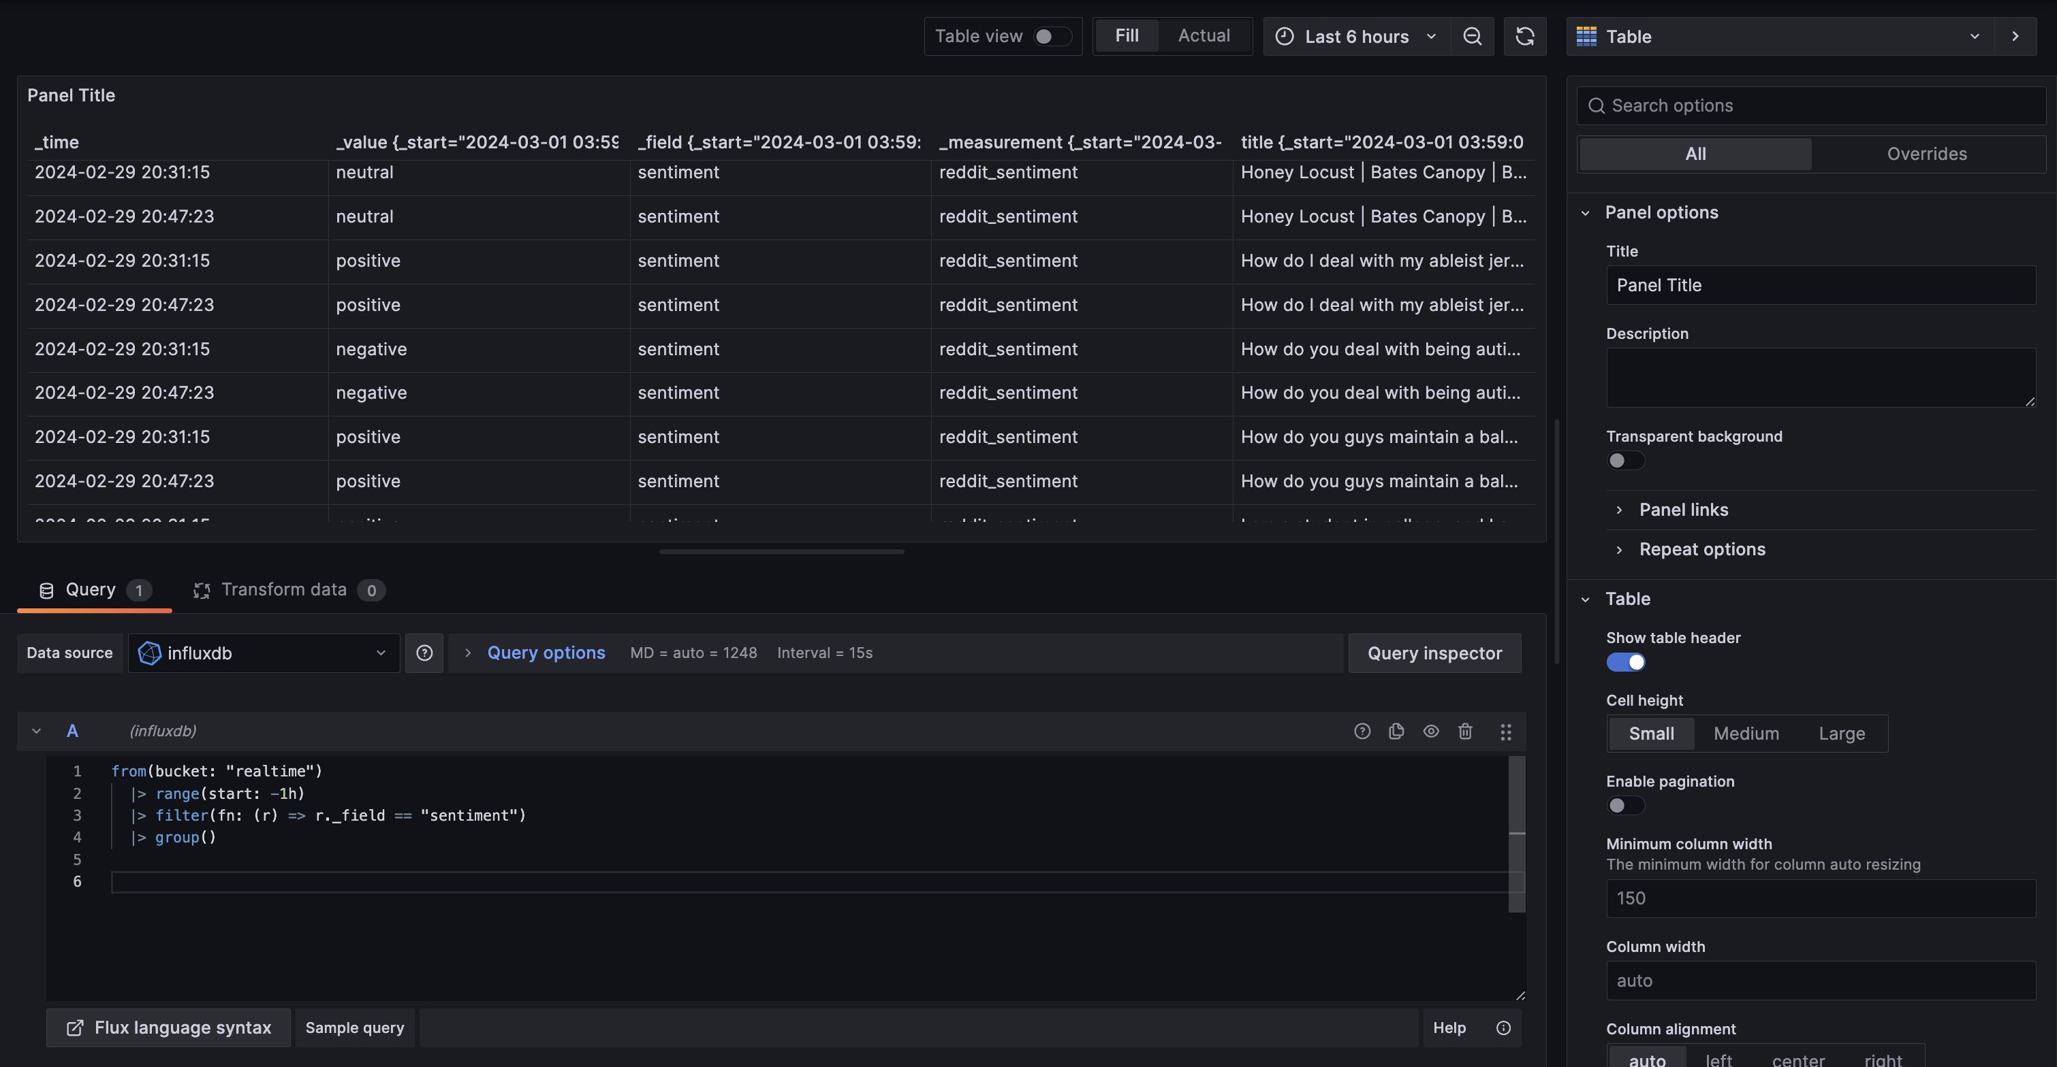

from(bucket: "realtime")

|> range(start: -1h)

|> filter(fn: (r) => r._field == "sentiment")

|> group()

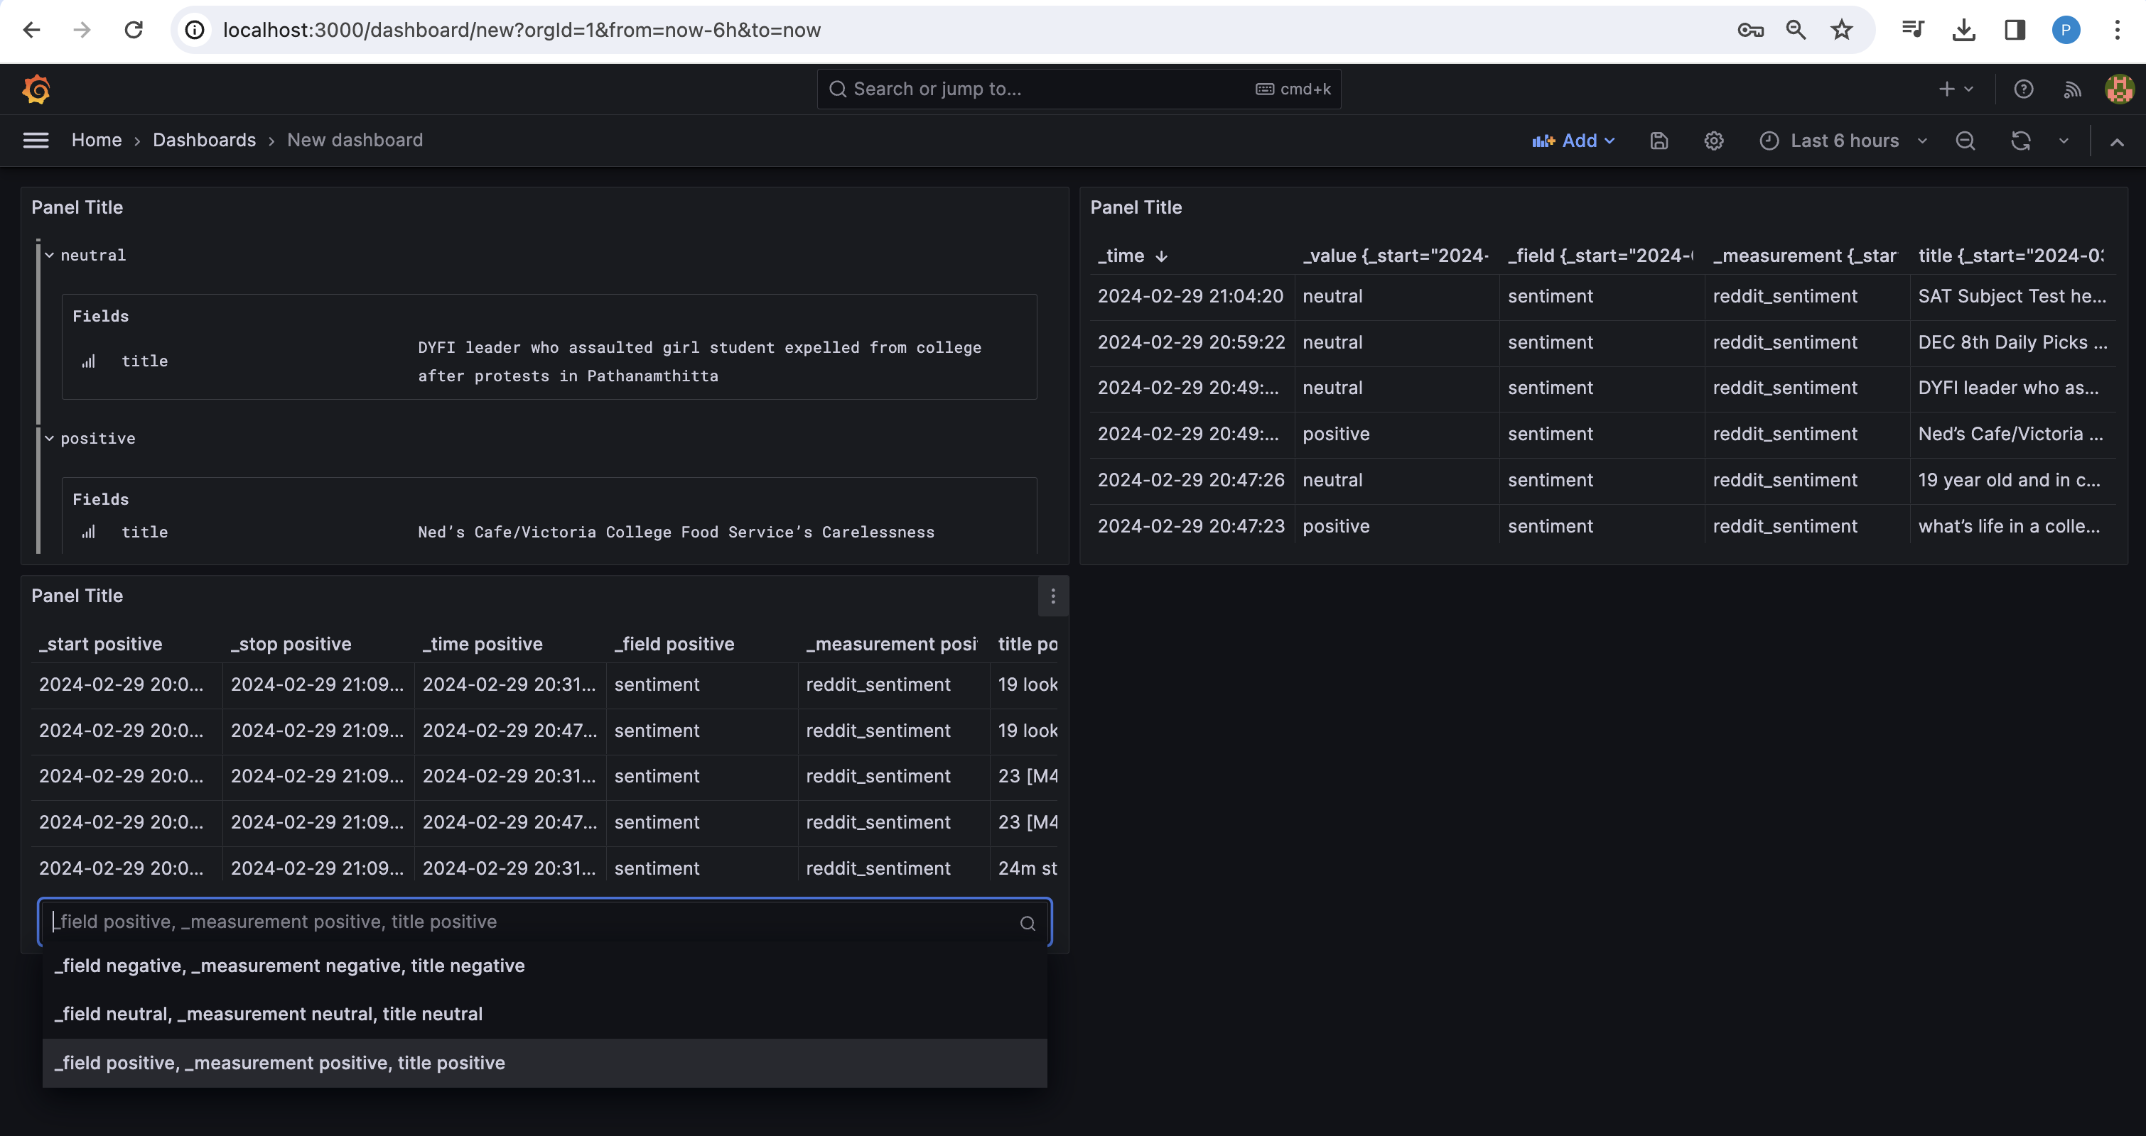

Simple Dashboard for real-time Analysis:

